* **Introduction:** Online shopping is a form of e-commerce which provides customers, the ability to browse and buy huge range of goods and services from sellers over the internet using different web browsers or mobile applications. Online shopping is related to life styles now a days. When people unable to shop offline as it's time consuming and also tiresome for some people, it's convenient to shop online. Moreover, perks of online shopping include, people can get things online that they cannot get in local markets or super markets. Plus, most of the e-retail shops give huge discounts to their customers. Now, we all know there are so many websites or mobile applications are ongoing, but according to the customers, all of the online shops are not capable of providing great deals or services all the times. And for that customer churn happens. And we have to analysed various things that maybe helpful to retain the customers.
* **Problem Statement**: Customer satisfaction has emerged as one of the most important factors that guarantee the success of online store; it has been posited as a key stimulant of purchase, repurchase intentions and customer loyalty. A comprehensive review of the literature, theories and models have been carried out to propose the models for customer activation and customer retention. Five major factors that contributed to the success of an e-commerce store have been identified as: service quality, system quality, information quality, trust and net benefit. The research furthermore investigated the factors that influence the online customers repeat purchase intention. The combination of both utilitarian value and hedonistic values are needed to affect the repeat purchase intention (loyalty) positively. The data is collected from the Indian online shoppers. Results indicate the e-retail success factors, which are very much critical for customer satisfaction. Be careful: There are two sheets (one is detailed) and second is encoded in the excel file. You may use any of them by extracting in separate excel sheet. The number of column(s) is more than 47. Read the column header carefully.

Note : Data Scientists have to apply their analytical skills to give findings and conclusions in detailed data analysis written in jupyter notebook . Only data analysis is required.

Need not to create machine learning models /but still if anybody comes with it that is welcome.

* **Loading and reading the dataset**:

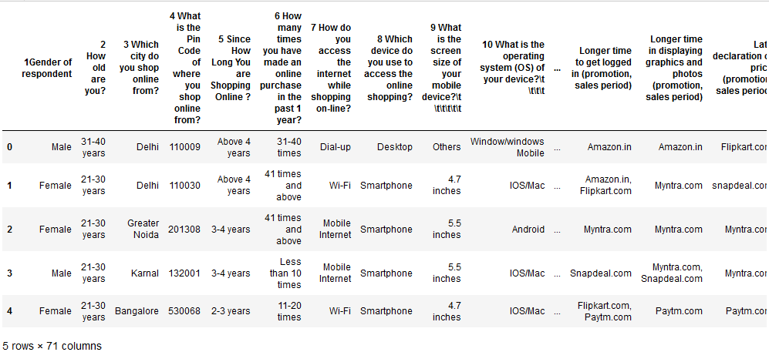

* As we can see, this Customer retention dataset is containing 71 columns where the data contains a good blend of categorical and nominal values.
* We need to analyse all the variables and check the relations between the feature vs feature to understand the service quality, system quality, information quality, trust and net-profit and other factors of different e-commerce stores.

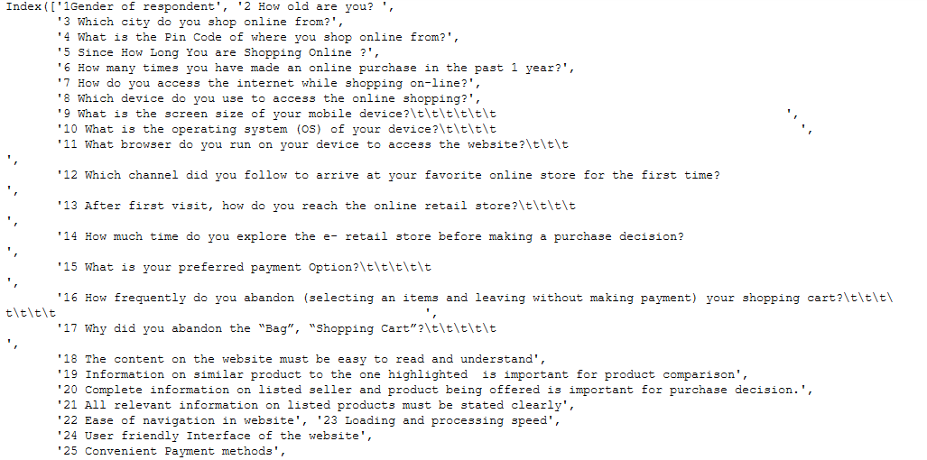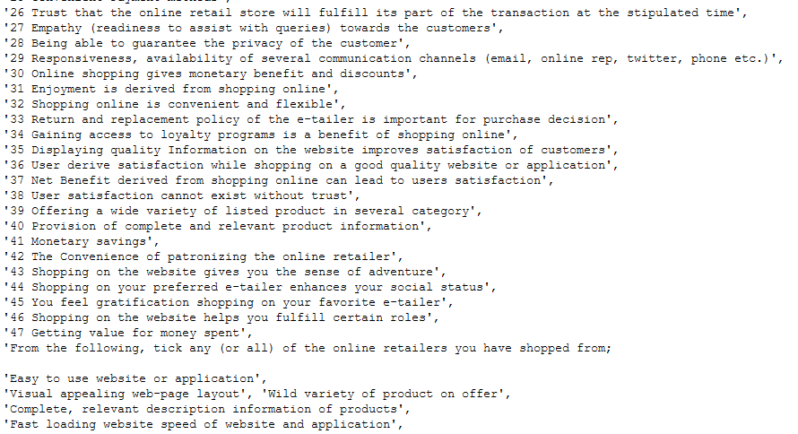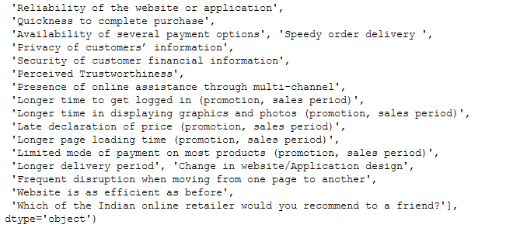

* As we can see, the 71 columns are actually different types of questions those have been asked to the customers to understand their point of view and experience regarding various e-commerce retail sectors.
* **Null Value detection**:

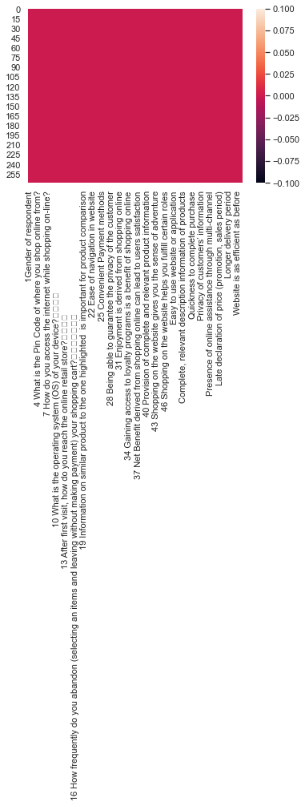

* There is no missing value present in the dataset.

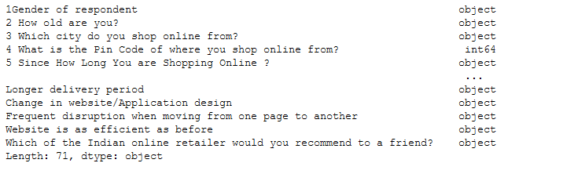

* Most of the columns in the dataset is containing object datatype values and rest are containing integer type of values.

**Exploratory Data Analysis:**

We will do **Univariate analysis**, **Bivariate analysis** and **Multivariate** analysis of the features. EDA will help us to understand the data more precisely and by visualization it will be helpful to understand which features are important than others. With those important features, the creation of the model will be more accurate and without bias.

**Univariate Analysis:**

We will do Univariate Analysis to understand the **count** of the **categorical** features. Let’s visualize,

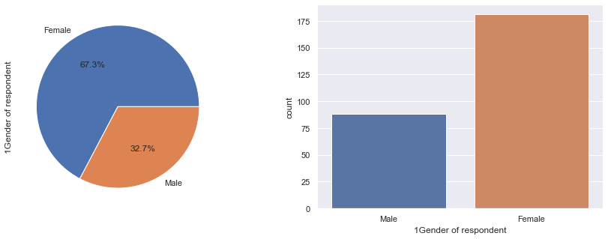

* Out of all the customers, that have been asked the several questions, female individuals are more in counts 181(67.3%) than the male individual counts i.e. 88 (32,7%).

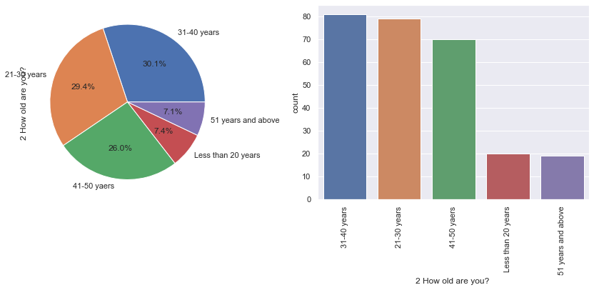

* There are 5 different age groups of individuals who have participated in the survey. The age group 31-40 years is highest in counts and the count is 81 (30.1%) and the age group 51 years and above is least in counts. The count is 19 (7.1%). In case of age groups, 21-30 years is in 2nd highest position 79 (29.4%) and 3rd highest is 41-50 years, it counts 70 (26.0%).

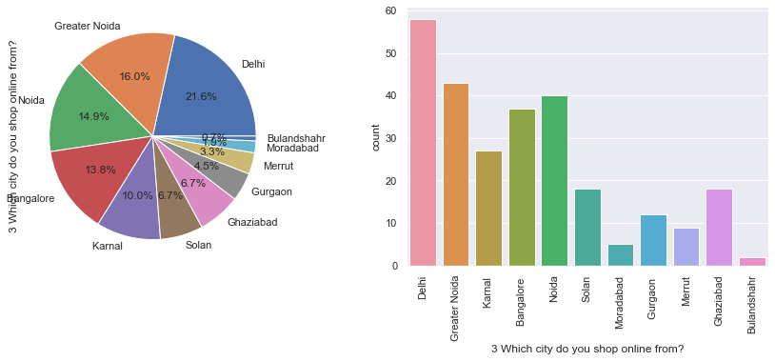

* People of Delhi mostly do online shopping than rest of the other cities, the count is 58 (21.6%) and least count people of Blandisher do shopping online. the count is 2 (0.7%).

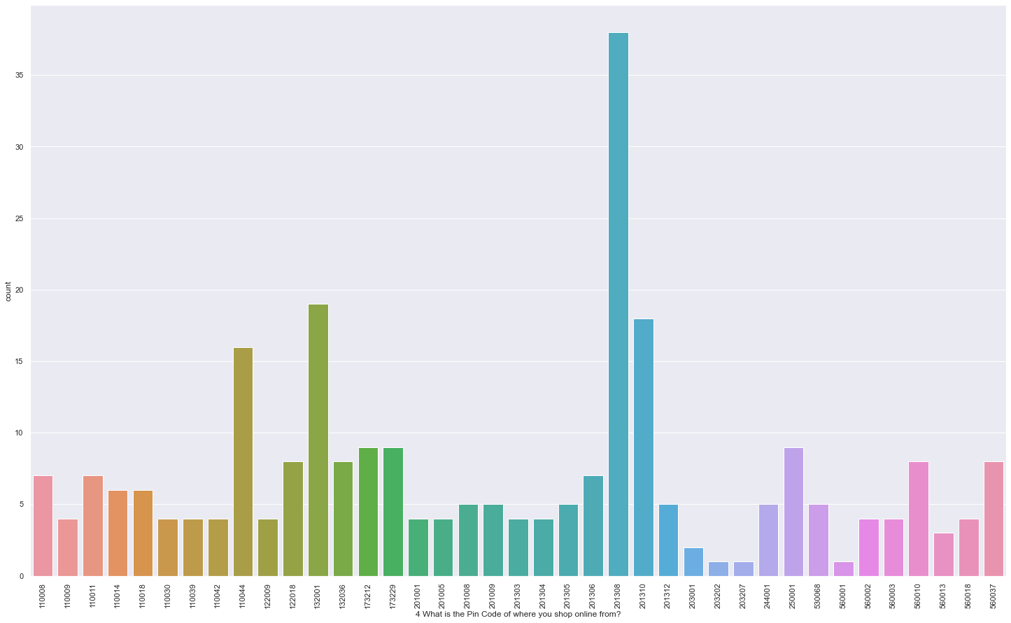

* People who belongs to the pin code 201308 are mostly active in online shopping as for the dataset than the rest of the localities.

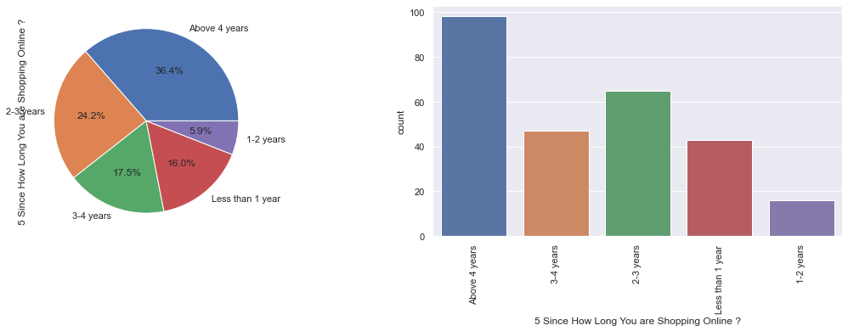

* The highest counts of people i.e. 98 (36.4%) are doing shopping online above 4 years and least counts of people do shopping online for 1-2 years.

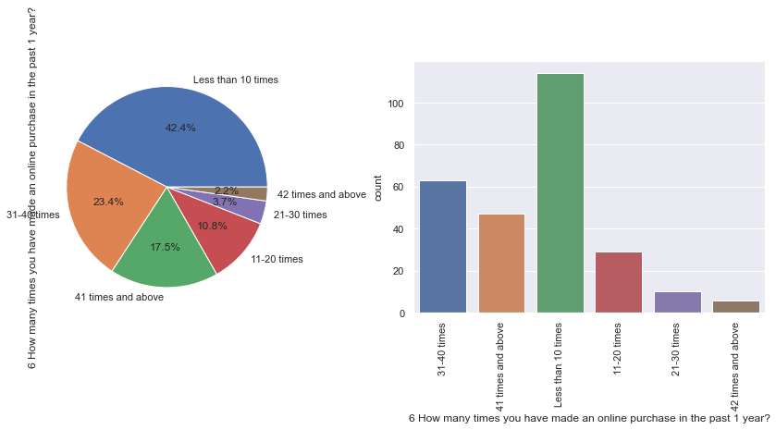

* People mostly do shopping online within 1 year is less than 10 times and the count is 114 (42.4%). And people who do shopping for 42 times and above, within a year are least in count 6 (2.2%).

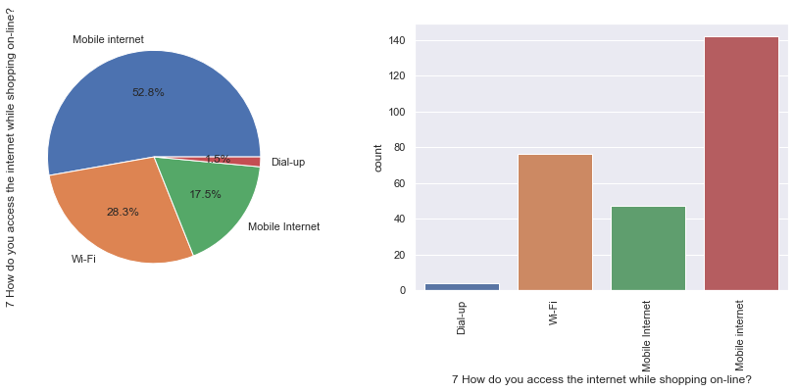

* People use their mobile internet to do shopping online mostly. The count is 142 (52.8%). But there is another column which is called mobile internet. Maybe both the columns are same. Then the count of mobile internet users for shopping online is 189. And least count of people use dial-up service to do online shopping, the count is 4 (1.5%). 2nd highest category is WIFI using customers. That counts 76.

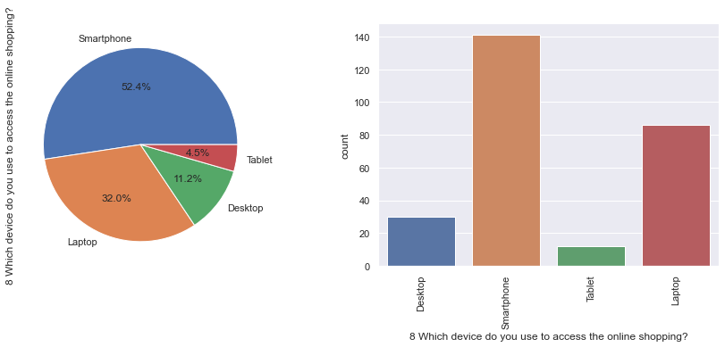

* People mostly use smartphones for online shopping. The count is 141 (52.4%) and least counts of people use Tablet for online shopping 12 (4.5%).

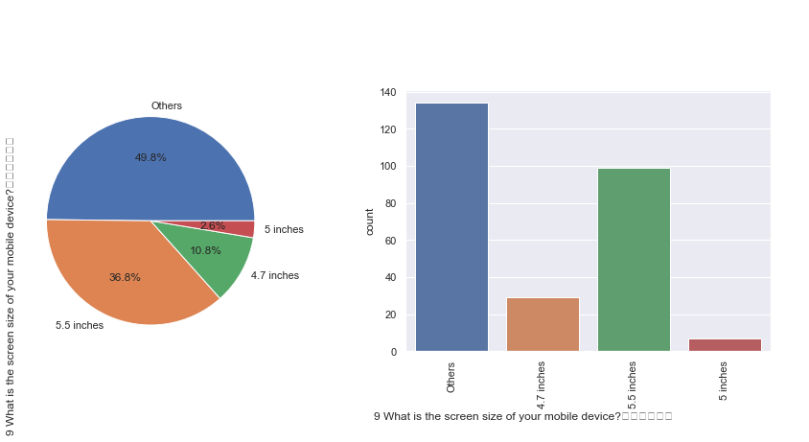

* People mostly use the mobile devices with screen sizes other (the count is 134 (49.8% of people use the other type))than 4.7 inches, 5.5 inches and 5 inches.

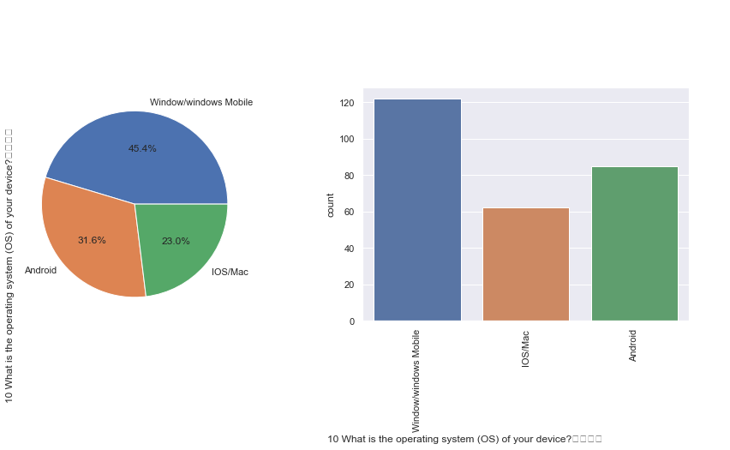

* People use mostly Windows/windows ( 122 (45.4% of people)) mobile operating system than IOS/Mac and Android.

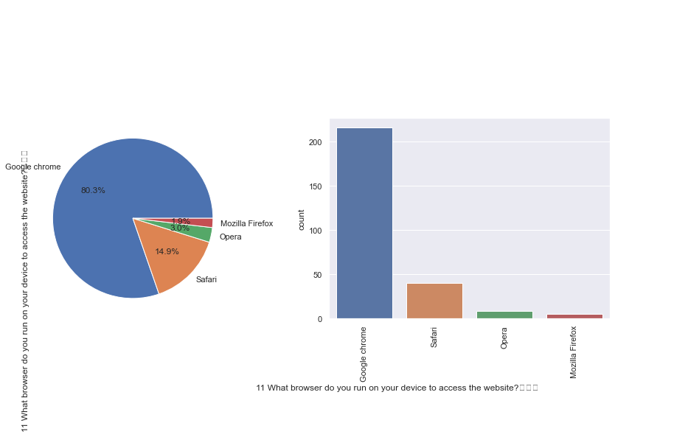

* People use Google Chrome to access the website the most ( 216 (80.3%)) and least using browser is Mozilla Firefox and it counts 5 ( 1.9% ).

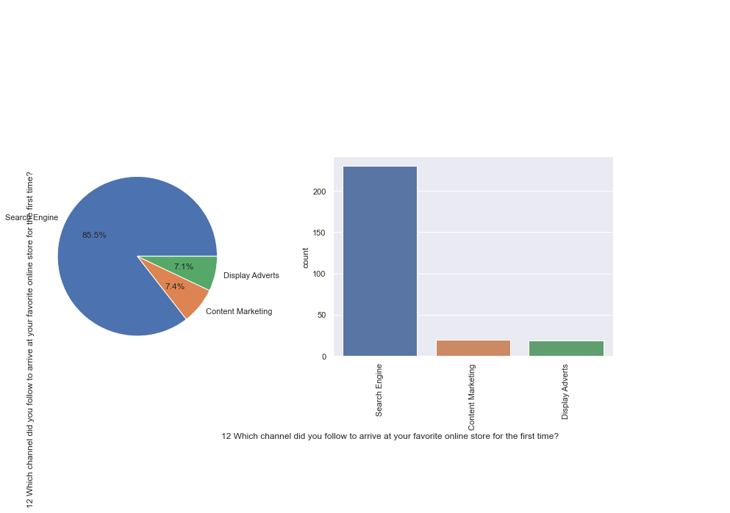

* People mostly follow Search Engines to arrive at their favourite online store for the first time. The count is 230 (85.5%). They rarely follow content marketing and display adverts to arrive at their favourite online stores. The count is 20 ( 7.4% ) and 19 ( 7.1% ) respectively.

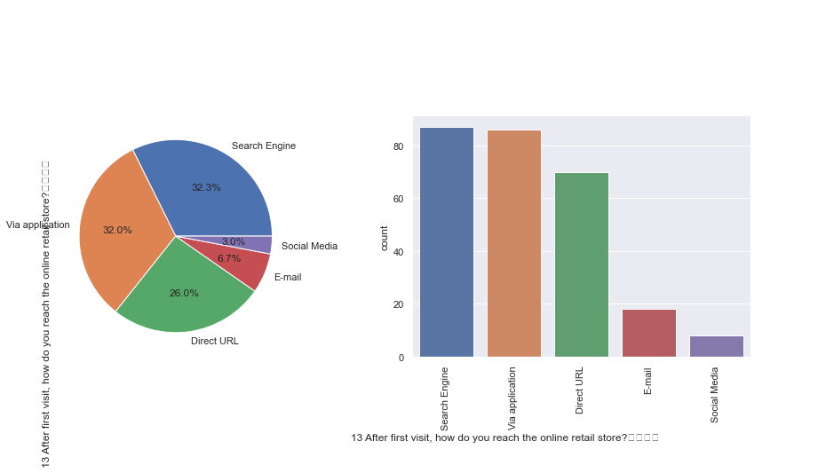

* After first visit also highest count of people follow Search Engines to arrive at the online retail stores. The count is 87 (32.3%). And 2nd highest count of people reach the online retail stores via application. That counts 86 ( 32.0% ). Lest count of people reach through Social Media and the count is 8 ( 3.0% ).

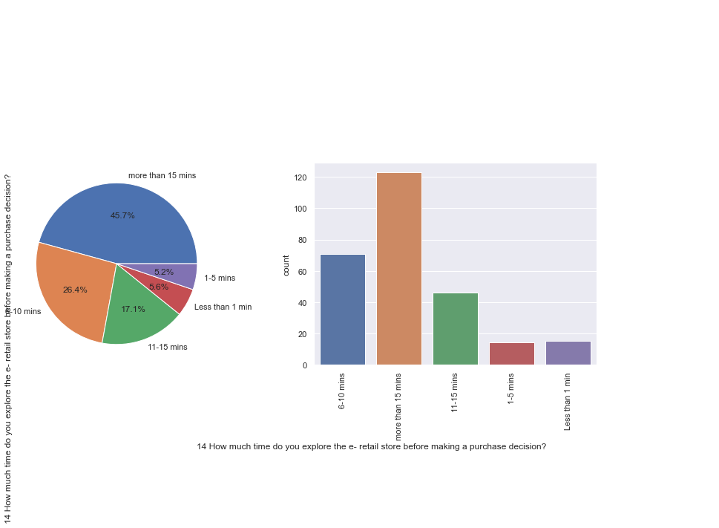

* People mostly explore the e-retail store for more than 15 minutes before making a purchase decision. The count is 123 ( 45.7% ). Least number of people explore the e-retail store for 1-5 minutes before making a purchase decision. The count is 14 ( 5.2% ).

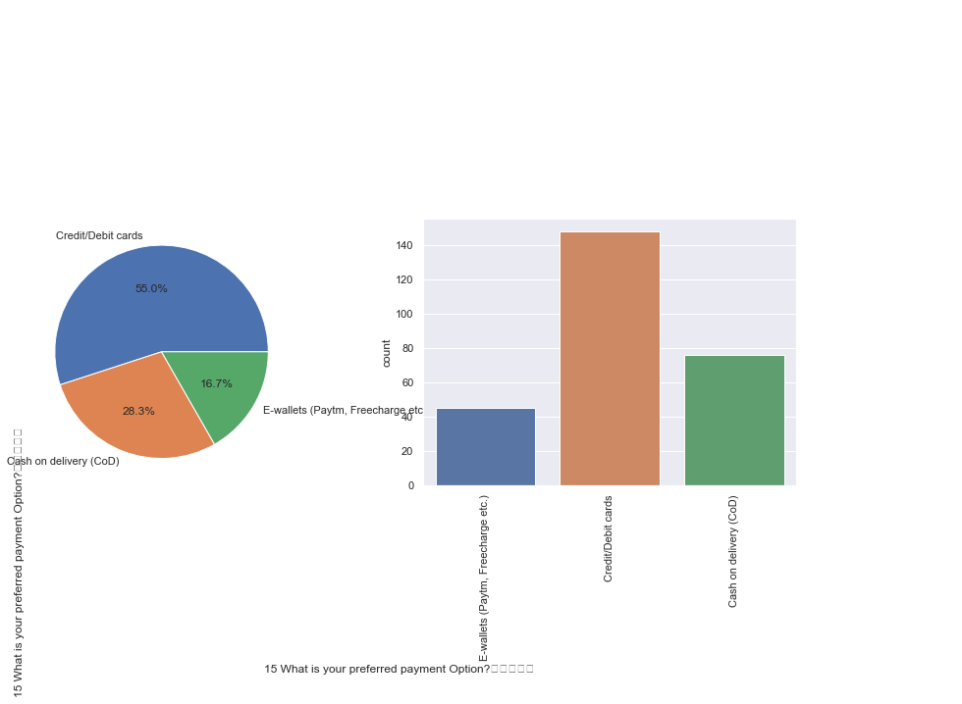

* People mostly use Credit/Debit cards to do online shopping, The count is 148 ( 55.0% ) and least count of people use E-wallets(Paytm,Freecharge etc.). It counts 45 (16.7%).

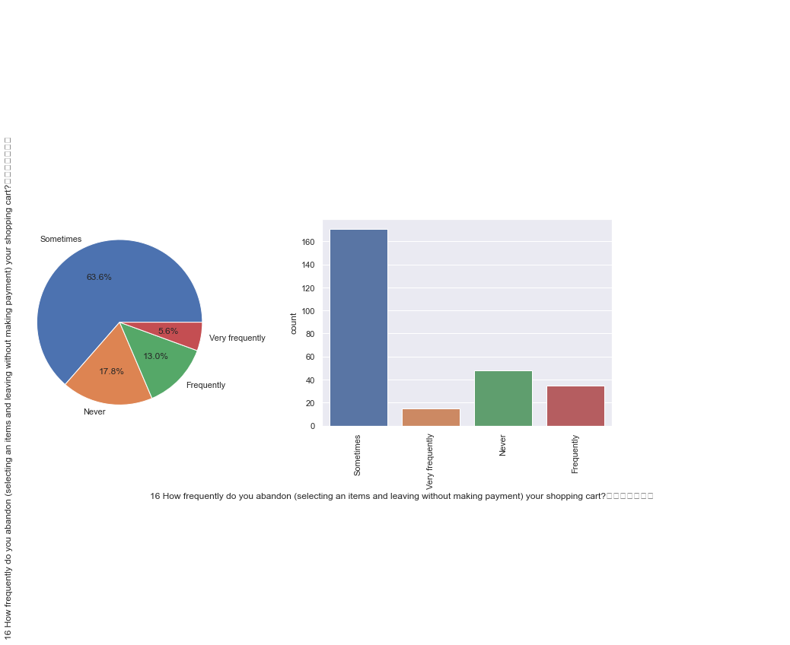

* Highest count of people sometimes abandon the shopping cart without making payment. It counts 171 ( 63.6% ) and least count of people very frequently abandon the shopping cart without making payment. It counts 15 ( 5.6% ).

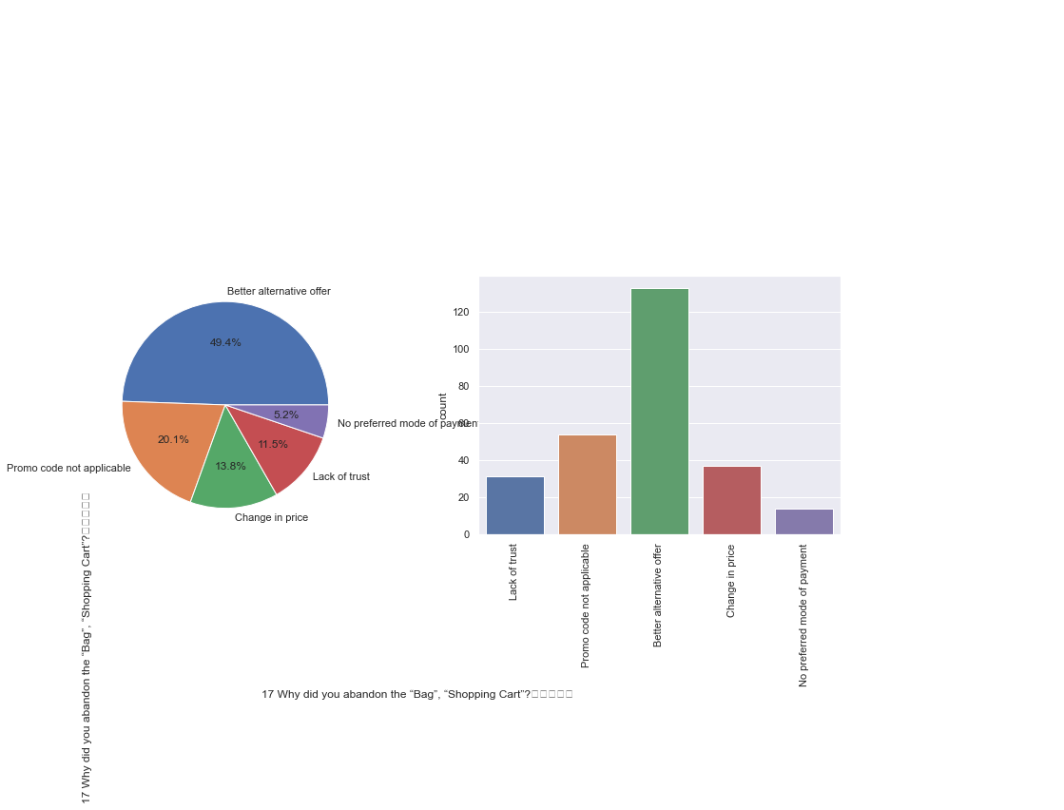

* Highest counts of people abandon the shopping cart for better alternative offer. It counts 133 ( 49.4% ). And least counts of people abandon the shopping cart for no preferred mode of payment. It counts 14 ( 5.2% ).

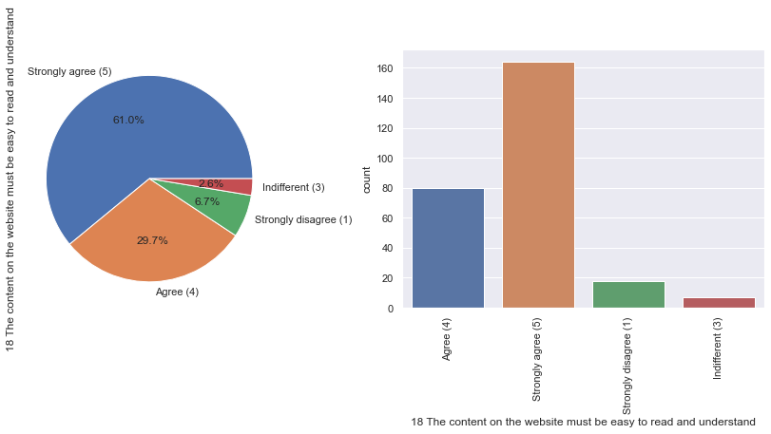

* Highest count of people are Strongly agreed(5) that the content on the website must be easy to read and understand. It counts 164 ( 61.0% ). And least count of people are indifferent(3). It counts 7 ( 2.6% ).

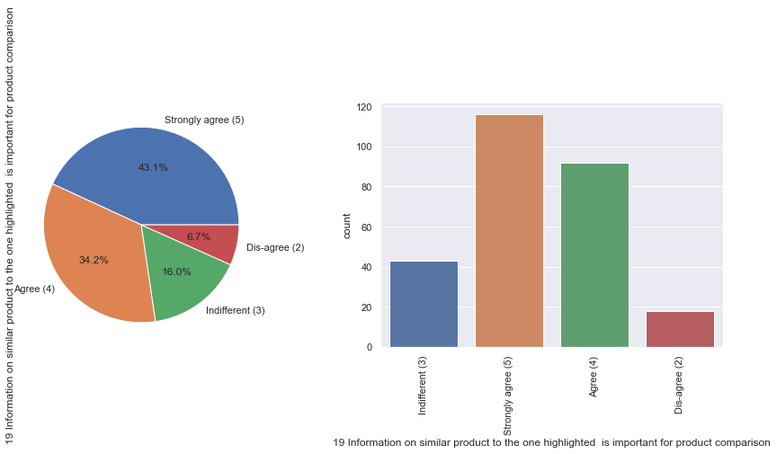

* Highest count of people are Strongly agreed(5) that information on similar product to the one highlighted is important for product comparison. It counts 116 ( 43.1% ). And least count of people are Dis-agreed (2) . It counts 18 ( 6.7% ).

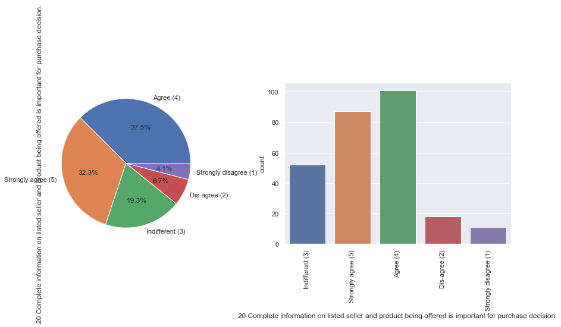

* Highest count of people are agreed(4) to complete information on listed seller and product being offered is important for purchase decision. It counts 101 ( 37.5% ). And least count of people are Strongly agreed(5) to it. It counts 11 ( 4.1% ).

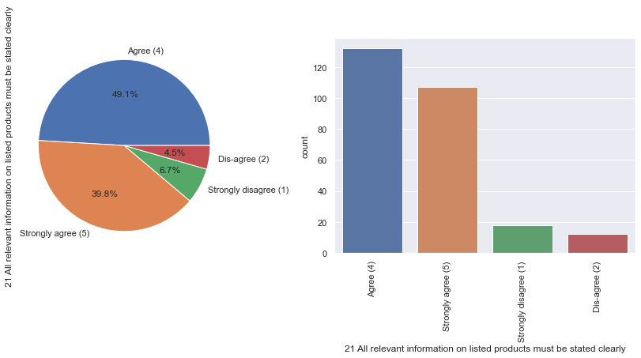

* Highest count of people are agreed(4) to all relevant information on listed products must be stated clearly. It counts 132 ( 49.1% ). And least count of people are Dis-agreed(2) to it. It counts 12 ( 4.5% ).

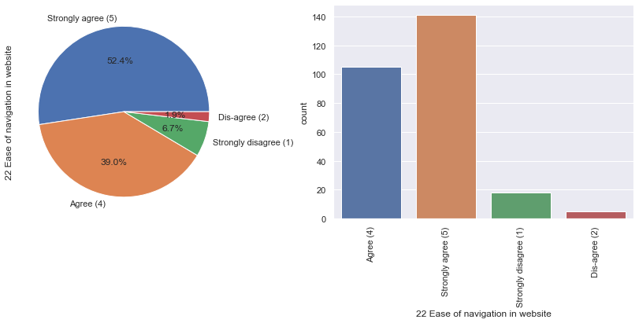

* Highest count of people are Strongly agreed(5) that there is ease of navigation in website. It counts 141 ( 52.4% ). And least count of people are Dis-agreed(2) to it. It counts 5 ( 1.9% ).

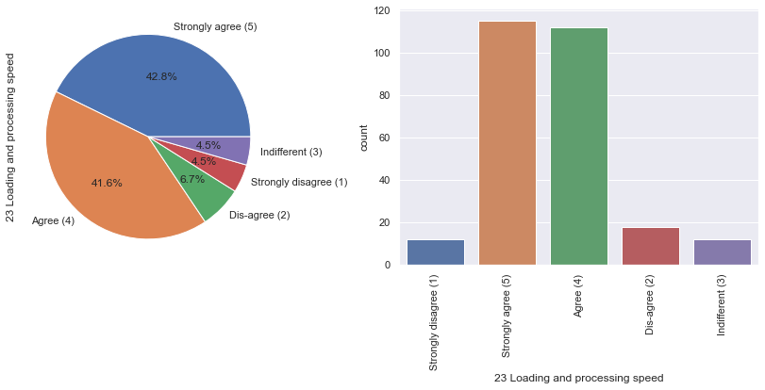

* Highest count of people are Strongly agreed(5) that loading and processing speed is important. It counts 115 ( 42.8% ). And least count of people are indifferent(3) to it. It counts 12 ( 4.5% ).

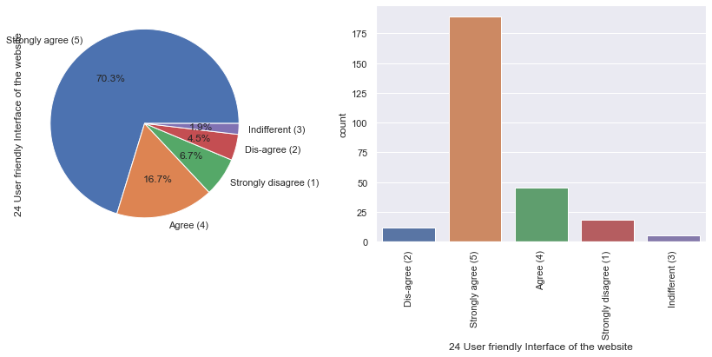

* Highest count of people are Strongly agreed(5) that there is user friendly Interface of the website. It counts 189 ( 70.3% ). And least count of people are indifferent(3) to it. It counts 5 ( 1.9% ).

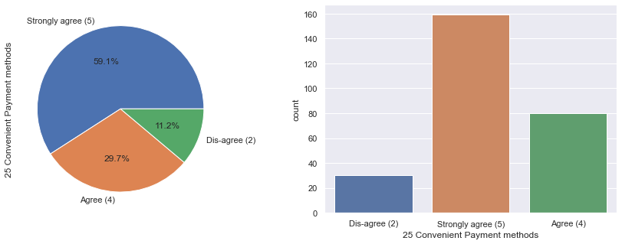

* Highest count of people are Strongly agreed(5) that there is convenient Payment methods. It counts 159 ( 59.1% ). And least count of people are dis-agreed(2) to it. It counts 30 ( 11.2% ).

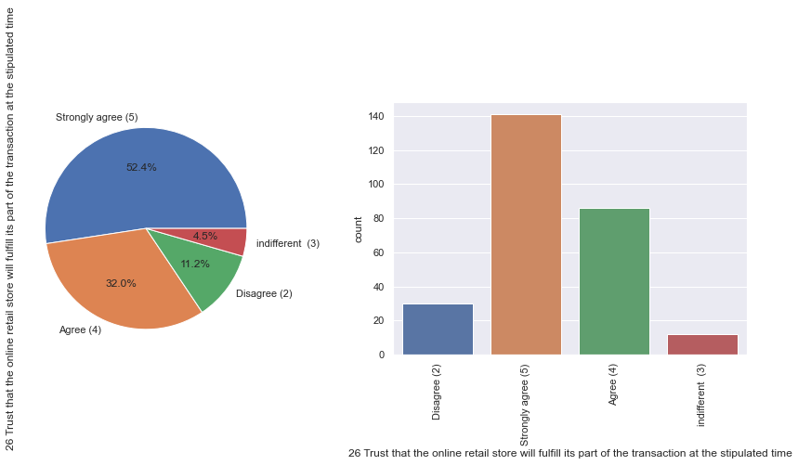

* Highest count of people are Strongly agreed(5) that there is trust that the online retail store will fulfil its part of the transaction at the stipulated time. It counts 141 ( 52.4% ). And least count of people are indifferent(3) to it. It counts 12 ( 4.5% ).

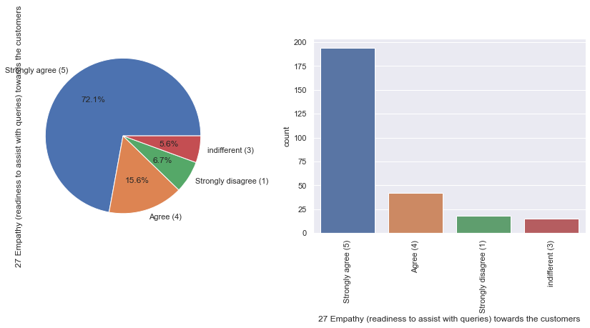

* Highest count of people are Strongly agreed(5) that there is empathy (readiness to assist with queries) towards the customers. It counts 194 ( 72.1% ). And least count of people are indifferent(3) to it. It counts 15 ( 5.6% ).

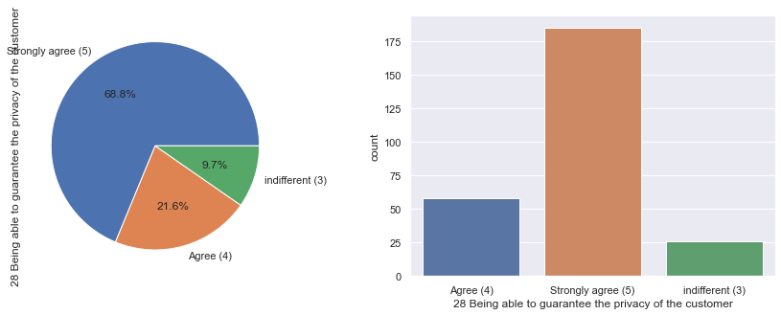

* Highest count of people are Strongly agreed(5) that the online stores are being able to guarantee the privacy of the customer. It counts 185 ( 68.8% ). And least count of people are indifferent(3) to it. It counts 26 ( 9.7% ).

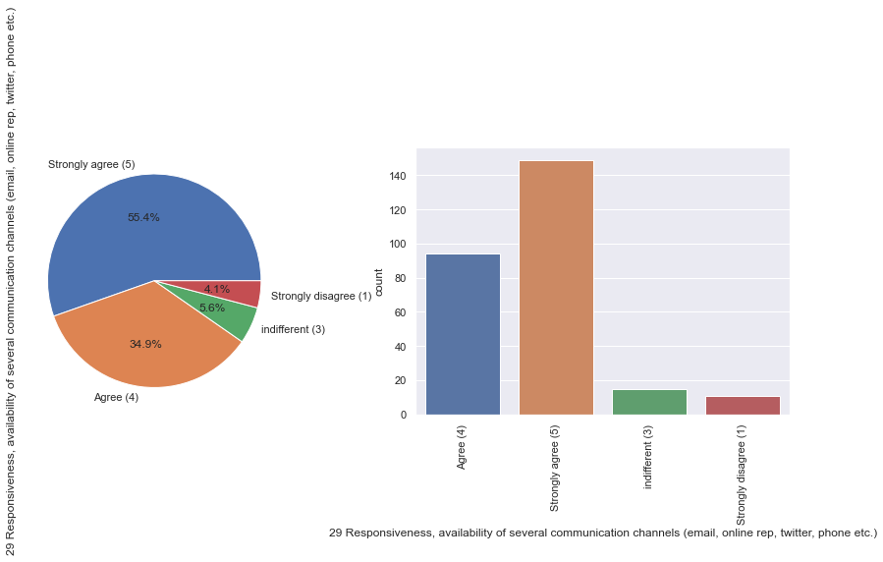

* Highest count of people are Strongly agreed(5) that the responsiveness, availability of several communication channels (email, online rep, twitter, phone etc.) are there in the e-retail stores. It counts 149 ( 55.4% ). And least count of people are strongly dis-agreed(1) to it. It counts 11 (4.1% ).

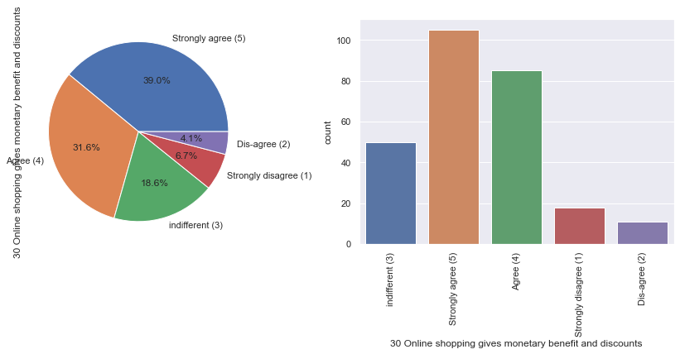

* Highest count of people are Strongly agreed(5) that online shopping gives monetary benefit and discounts. It counts 105 ( 39.0% ). And least count of people are dis-agreed(2) to it. It counts 11 (4.1% ).

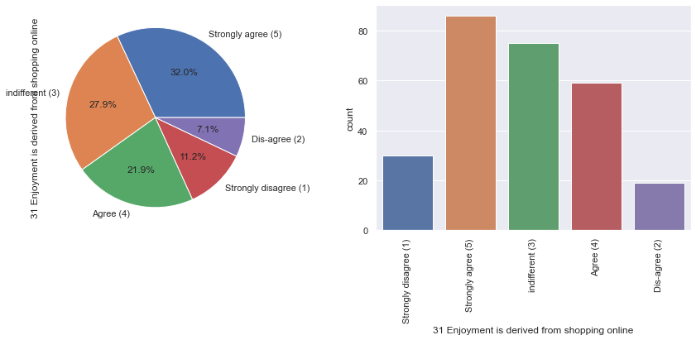

* Highest count of people are Strongly agreed(5) that enjoyment is derived from shopping online. It counts 86 ( 32.0% ). 2nd highest count of people are indifferent to it And least count of people are dis-agreed(2) to it. It counts 19 (7.1% ).

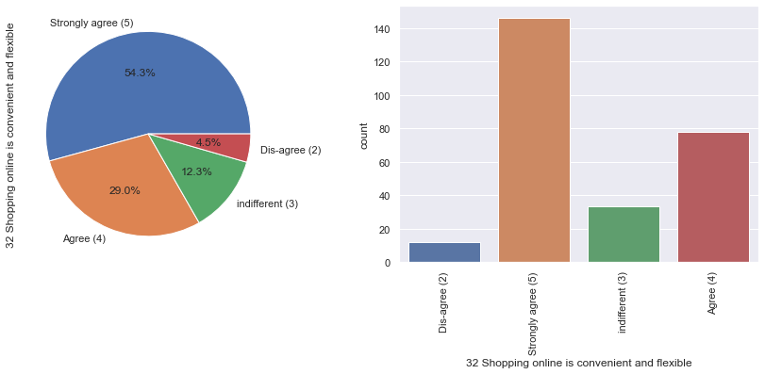

* Highest count of people are Strongly agreed(5) that shopping online is convenient and flexible. It counts 146 ( 54.3% ). And least count of people are dis-agreed(2) to it. It counts 12 (4.5% ).

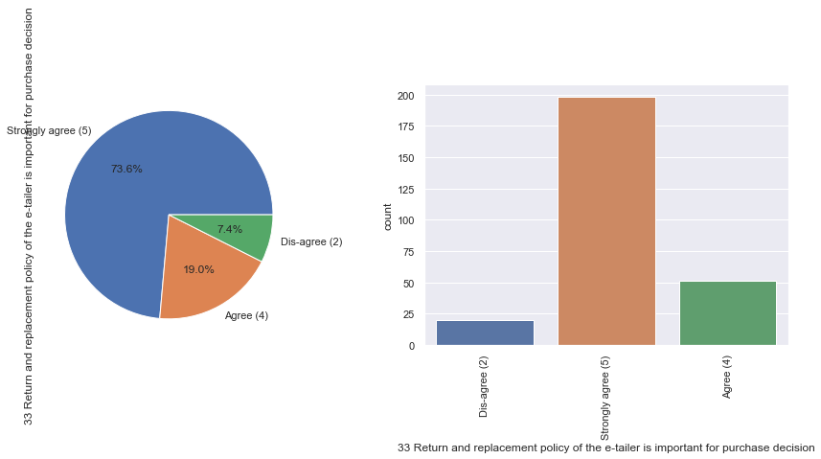

* Highest count of people are Strongly agreed(5) that return and replacement policy of the e-tailer is important for purchase decision. It counts 198 ( 73.6% ). And least count of people are dis-agreed(2) to it. It counts 20 (7.4% ).

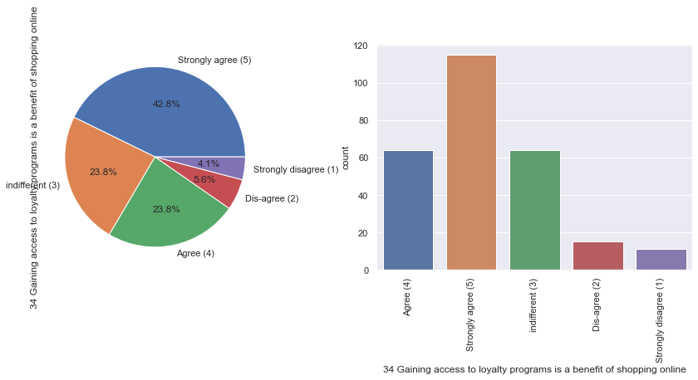

* Highest count of people are Strongly agreed(5) that gaining access to loyalty programs is a benefit of shopping online. It counts 115 ( 42.8% ). And least count of people are strongly dis-agreed(1) to it. It counts 11 (5.6% ).

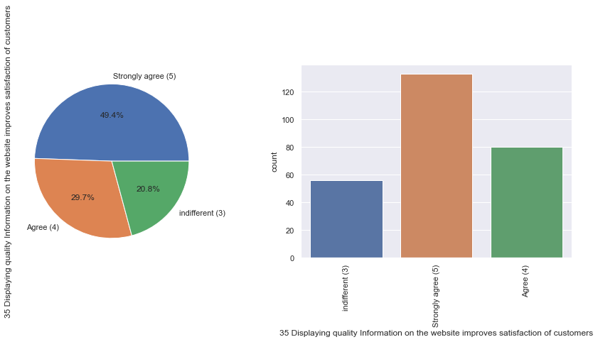

* Highest count of people are Strongly agreed(5) that displaying quality information on the website improves satisfaction of customers. It counts 133 ( 49.4% ). And least count of people are indifferent(3) to it. It counts 56 (20.8% ).

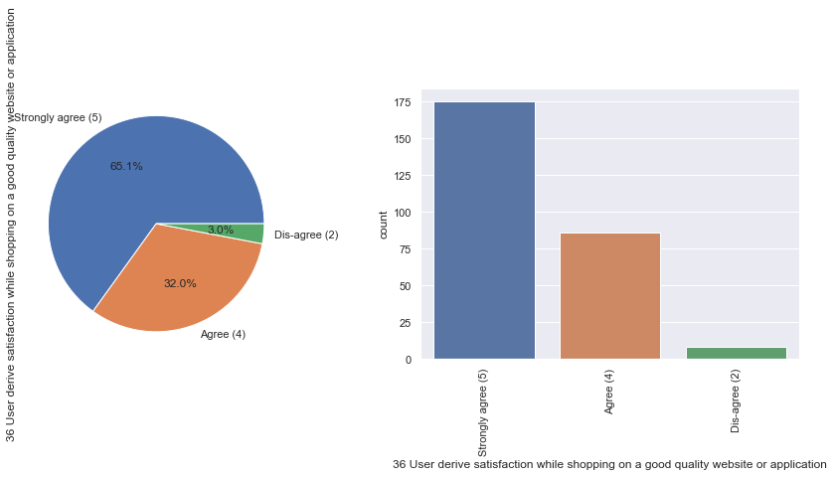

* Highest count of people are Strongly agreed(5) that users derive satisfaction while shopping on a good quality website or application. It counts 175 ( 65.1% ). And least count of people are dis-agreed(2) to it. It counts 8 (3.0% ).

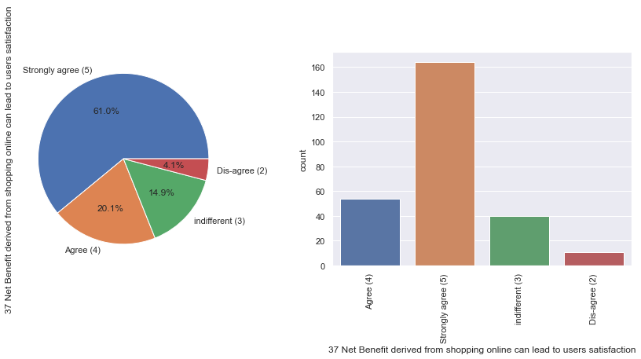

* Highest count of people are Strongly agreed(5) that Net Benefit derived from shopping online can lead to users satisfaction. It counts 164 ( 61.0% ). And least count of people are dis-agreed(2) to it. It counts 11 (4.1% ).

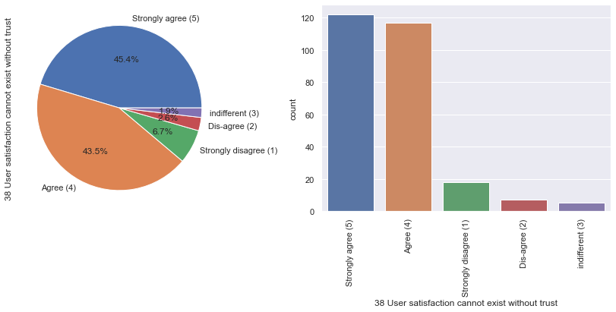

* Highest count of people are Strongly agreed(5) that user satisfaction cannot exist without trust. It counts 122 ( 45.4% ). And least count of people are indifferent(3) to it. It counts 5 (1.9% ).

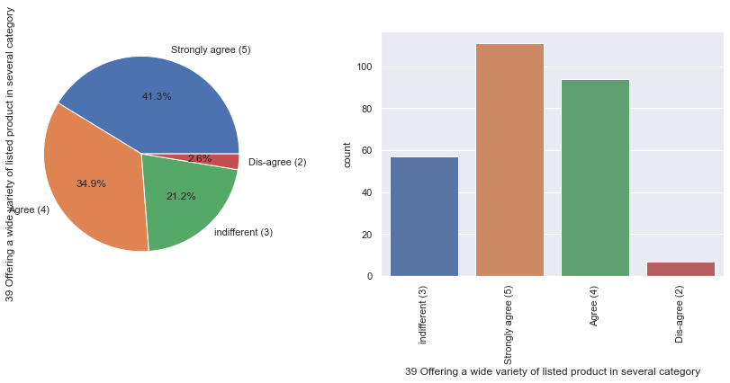

* Highest count of people are Strongly agreed(5) that the e-retail shops offer a wide variety of listed products in several category. It counts 111 ( 41.3% ). And least count of people are dis-agreed(2) to it. It counts 7 (2.6% ).

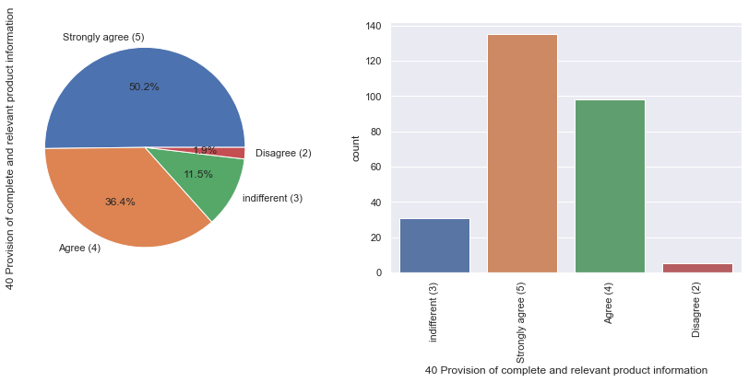

* Highest count of people are Strongly agreed(5) that there is a provision of complete and relevant product information in e-retail shops. It counts 135 ( 50.2% ). And least count of people are disagreed(2) to it. It counts 5 (1.9% ).

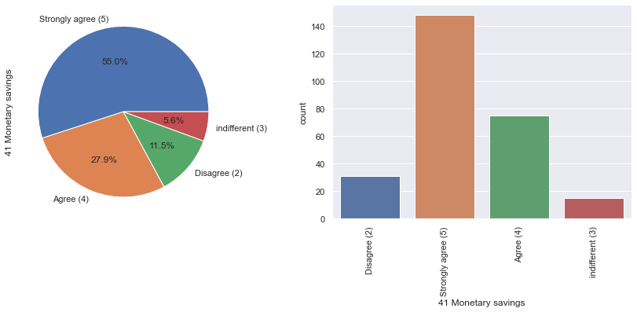

* Highest count of people are Strongly agreed(5) that there is a provision of monetary savings in e-retail shops. It counts 148 ( 55.0% ). And least count of people are indifferent(3) to it. It counts 15 (5.6% ).

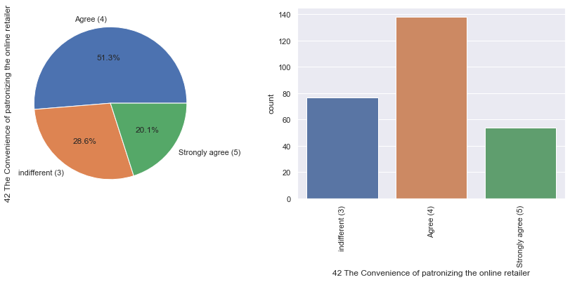

* Highest count of people are agreed(4) that there is a provision of convenience of patronizing the online retailer. It counts 138 ( 51.3% ). And least count of people are strongly agreed to it. It counts 54 (20.1% ).

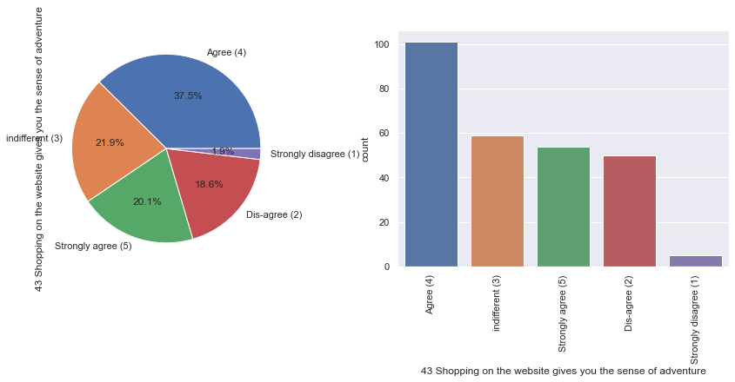

* Highest count of people are agreed(4) that shopping on the website gives them the sense of adventure. It counts 101 ( 37.5% ). And least count of people are strongly disagreed(1) to it. It counts 5 (1.9% ).

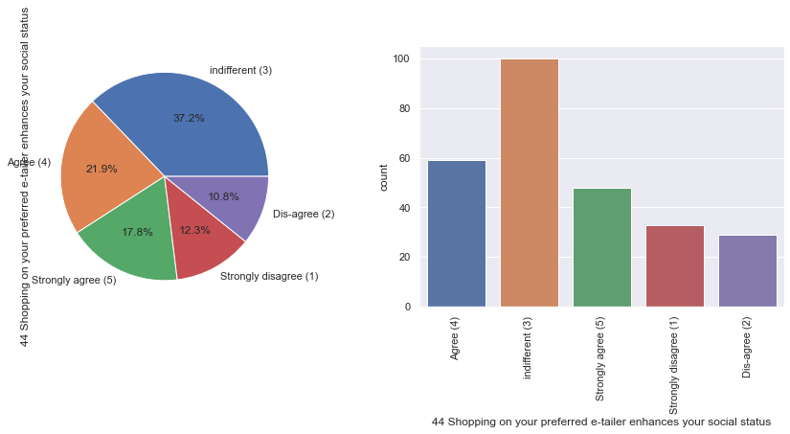

* Highest count of people are indifferent(3) that shopping on your preferred e-tailer enhances your social status. It counts 100 ( 37.2% ). And least count of people are disagreed(2) to it. It counts 29 ( 10.8% ).

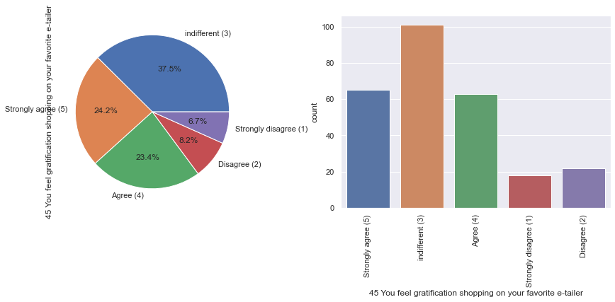

* Highest count of people are indifferent(3) that they feel gratification shopping on your favourite e-tailer. It counts 101 ( 37.5% ). And least count of people are strongly disagreed(1) to it. It counts 18 ( 6.7% ).

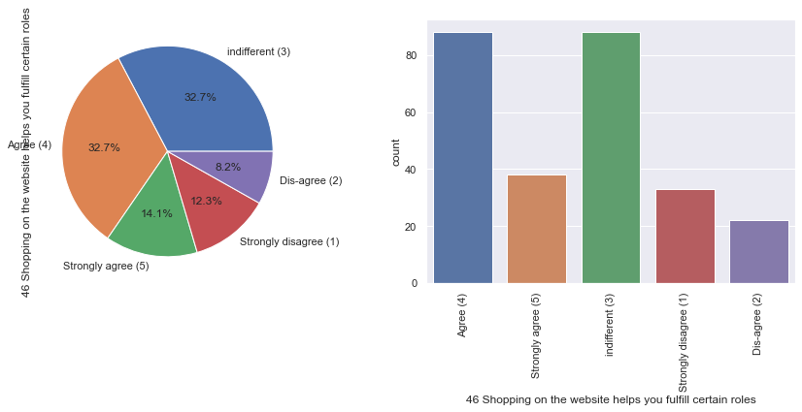

* Highest count of people are indifferent(3) and agreed(5) that they shopping on the website helps them full fill certain roles. It counts 88( 32.7% ) and 88( 32.7% ) respectively. And least count of people are disagreed(2) to it. It counts 22 ( 8.2% ).

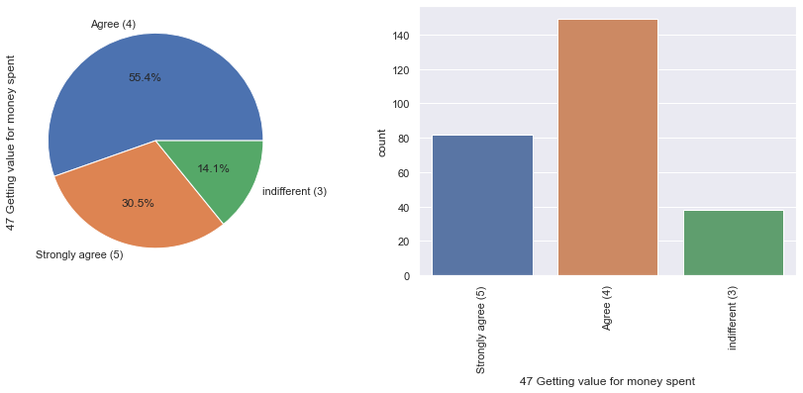

* Highest count of people are agreed(4) that e-retail shops are getting value for money spent. It counts 149 ( 55.4% ). And least count of people are indifferent to it. It counts 38 ( 14.1% ).

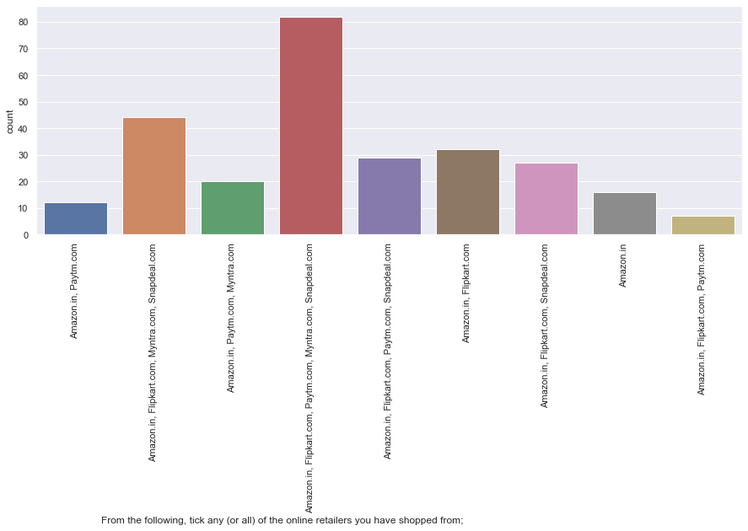

* Amazon.in, Flipkart.com, Paytm.com, Myntra.com, Snapdeal.com are the online retailers that people have shopped from mostly. It counts 82 .

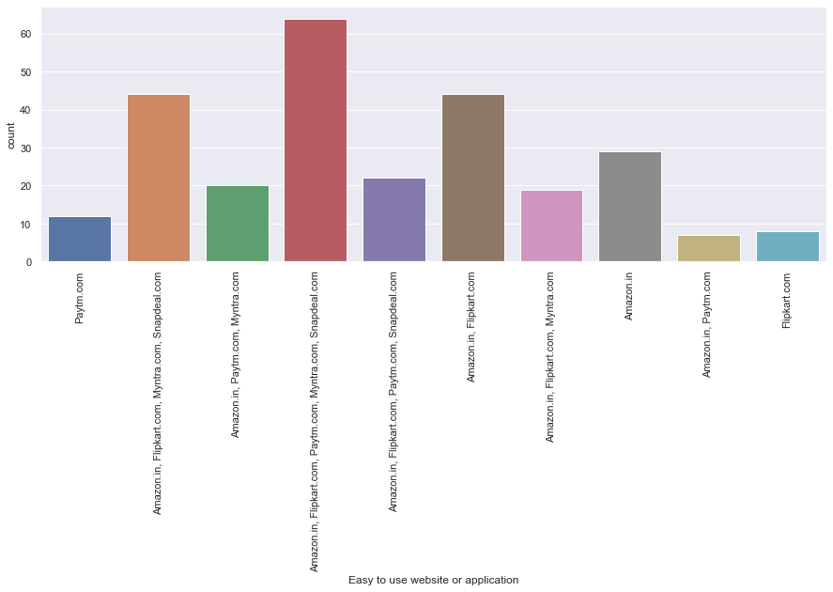

* **Amazon.in, Flipkart.com, Paytm.com, Myntra.com, Snapdeal.com** are the online retailers that highest count(64) of people think that these are easy to use websites or applications.

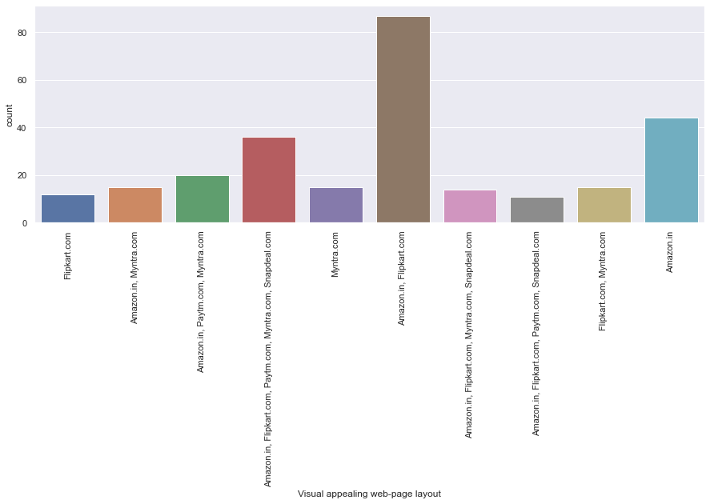

* **Amazon.in, Flipkart.com** are the online retailers that highest count(87) of people think that these are Visual appealing web-page layout.

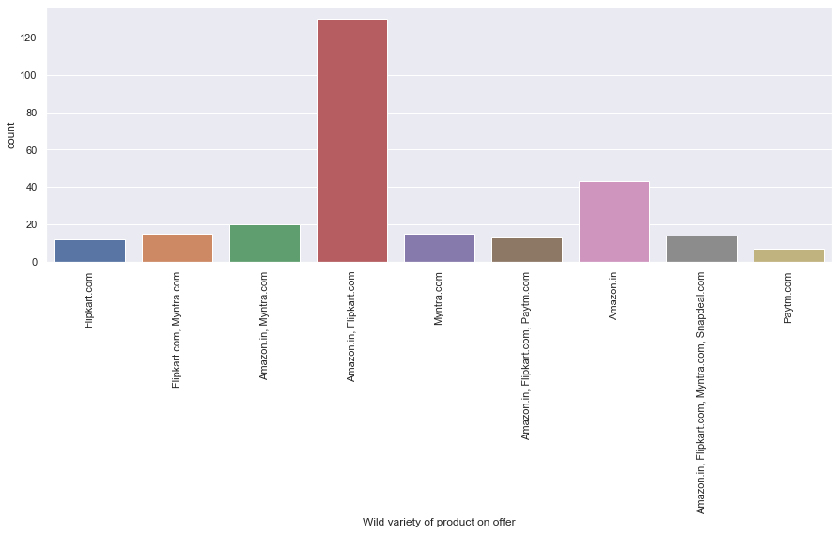

* Amazon.in, Flipkart.com are the online retailers that has got highest count (130) of people think they are having wild variety of product on offer.

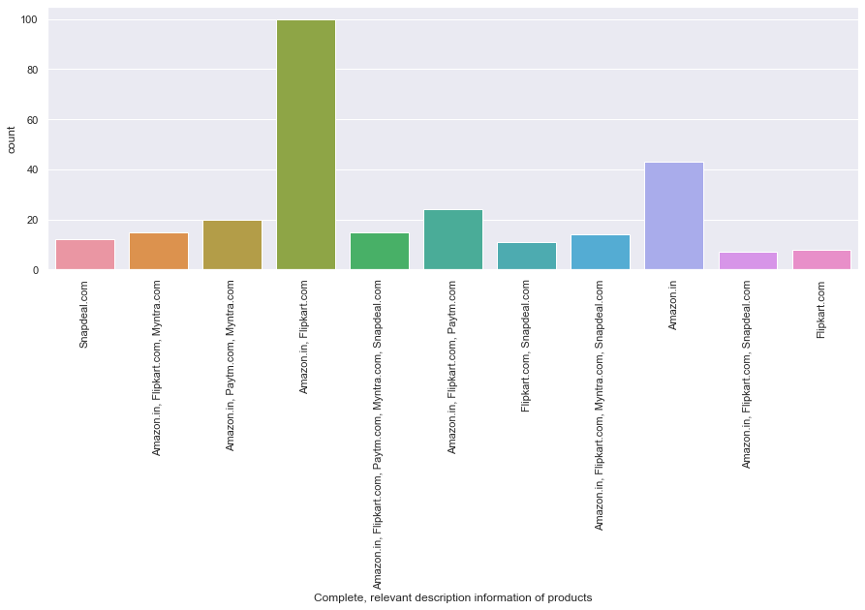

* Amazon.in, Flipkart.com are the online retailers that has got highest count (100) of people who think complete, relevant description information of products.

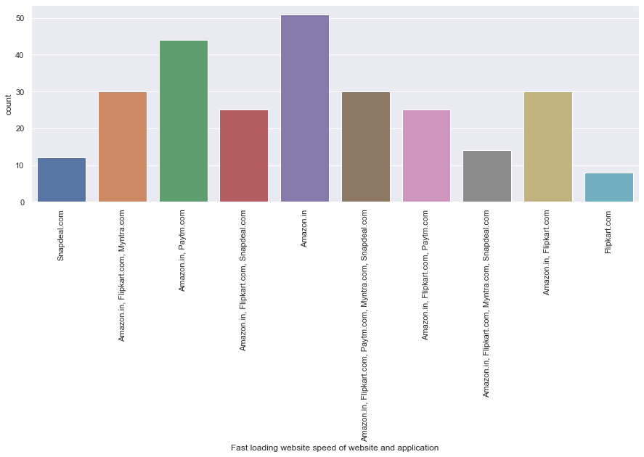

* Amazon.in is the fastest loading website or application according to highest count (51) of online customers.

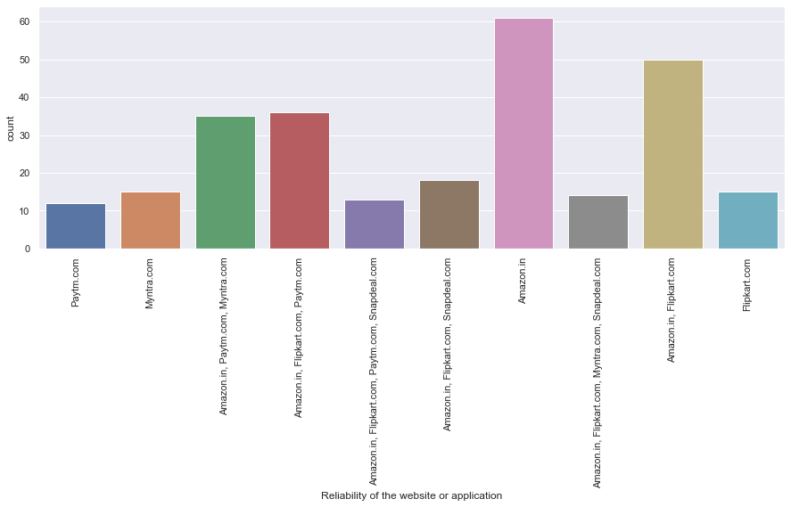

* Amazon.in is the most reliable website or application according to highest count (61) of online customers.

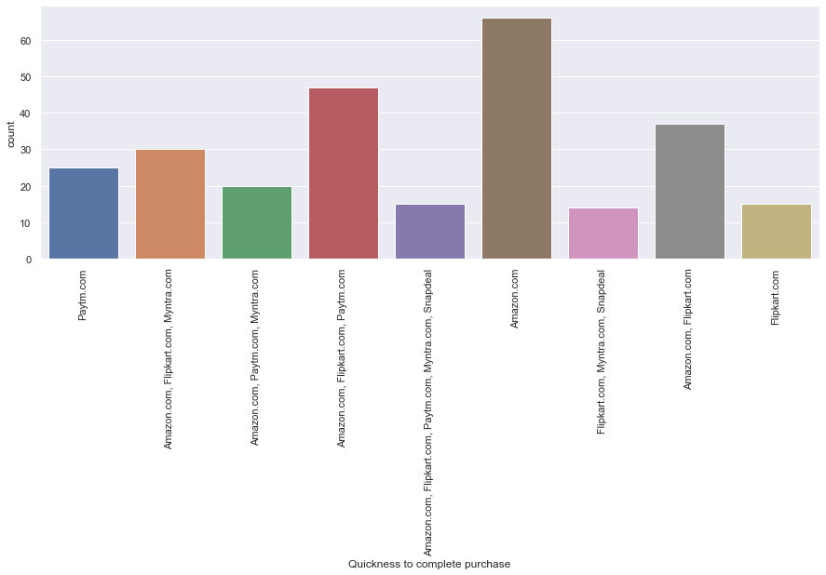

* Amazon.in is the quickest to complete purchase according to highest count (66) of online customers.

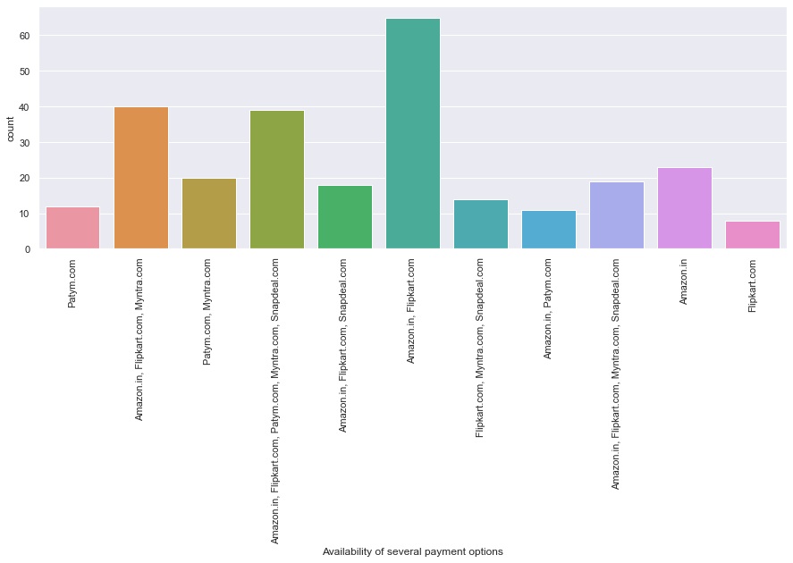

* Amazon.in, Flipkart.com are having several payment options according to highest count (65) of online customers.

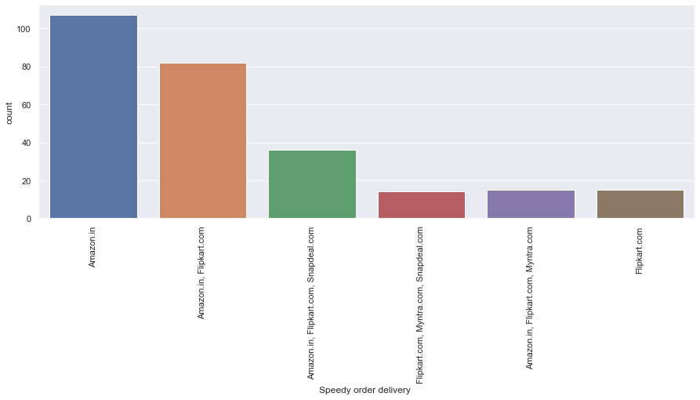

* Amazon.in is providing speedy order delivery according to highest count (107) of online customers.

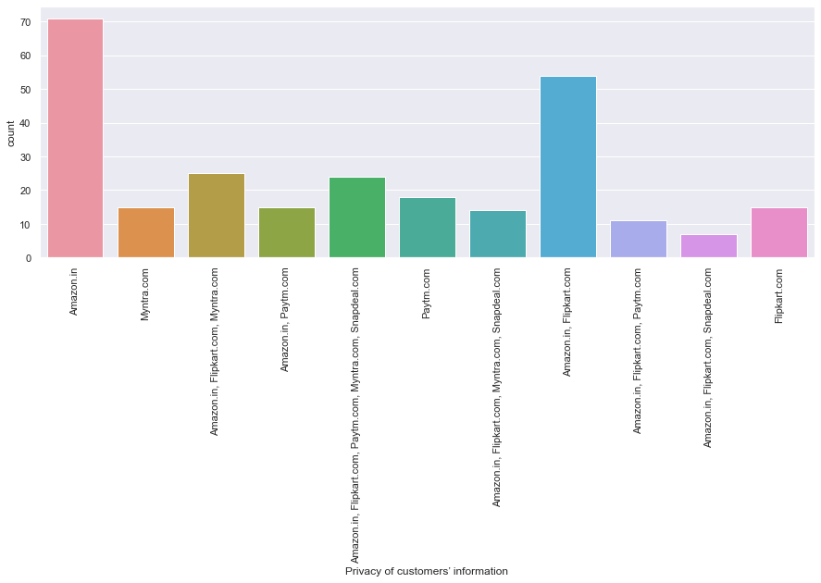

* Amazon.in is providing highest privacy of customers’ information according to highest count (71) of online customers.

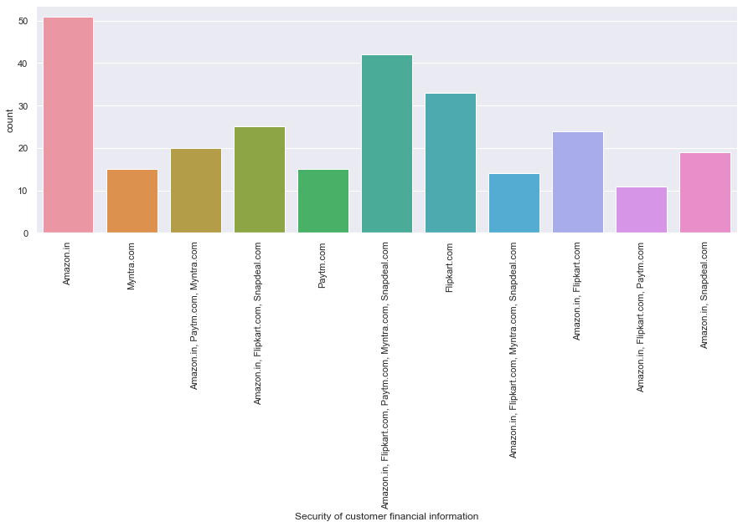

* Amazon.in is providing highest Security of customer financial information according to highest count (51) of online customers.

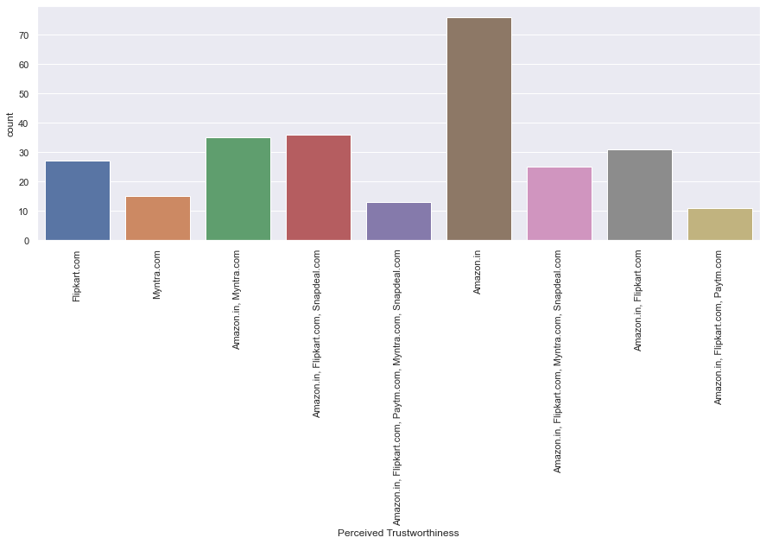

* Amazon.in is providing highest perceived trustworthiness according to highest count (76) of online customers.

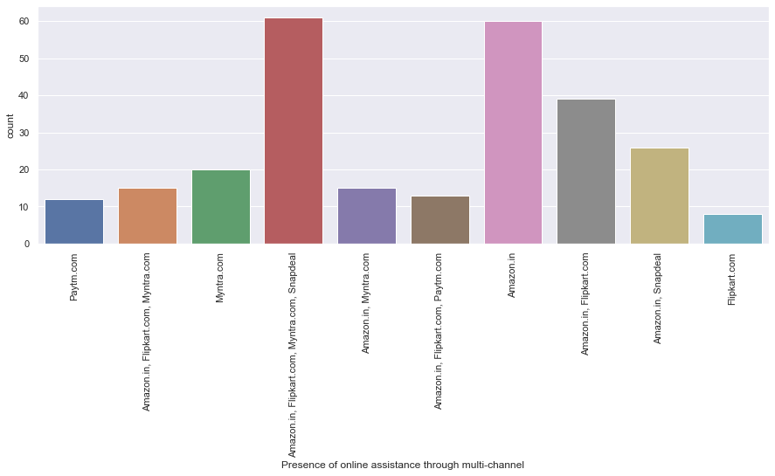

* Amazon.in, Flipkart.com, Myntra.com, Snapdeal are providing online assistance through multi-channel according to highest count (61) of online customers.

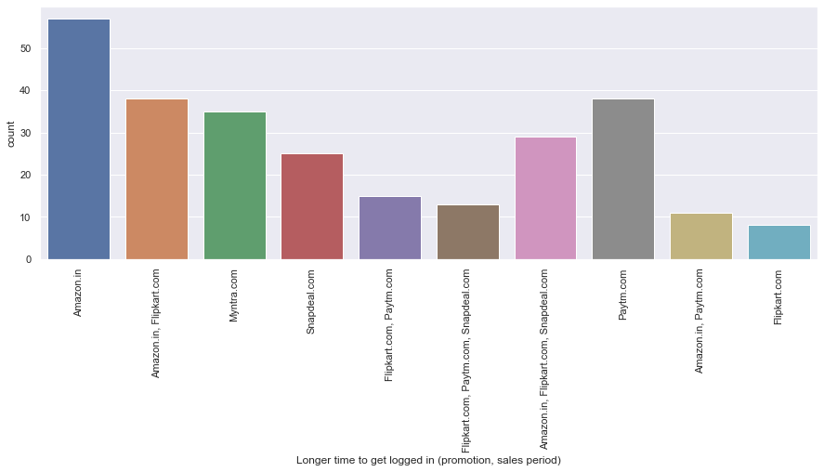

* Amazon.in take longer time to get logged in (promotion, sales period) according to highest count (57) of online customers.

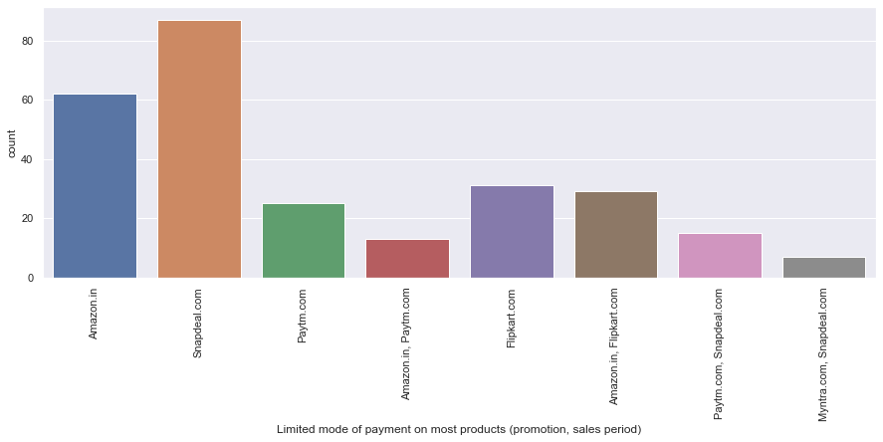

* Snapdeal.com has limited mode of payment on most products (promotion, sales period) according to highest count (87) of online customers.

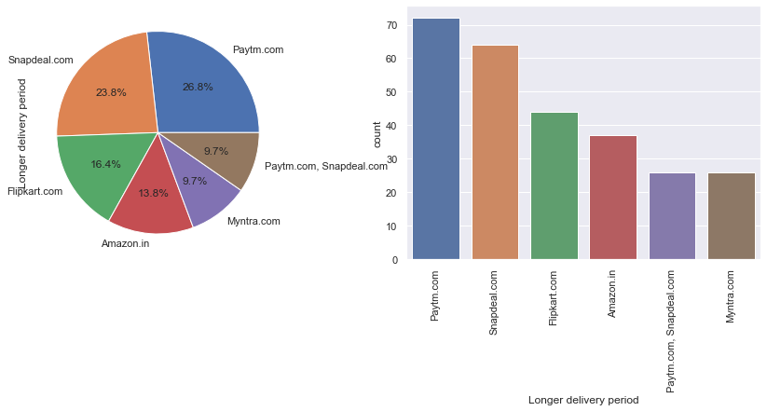

* Paytm.com take Longer delivery period according to highest count (72) of online customers.

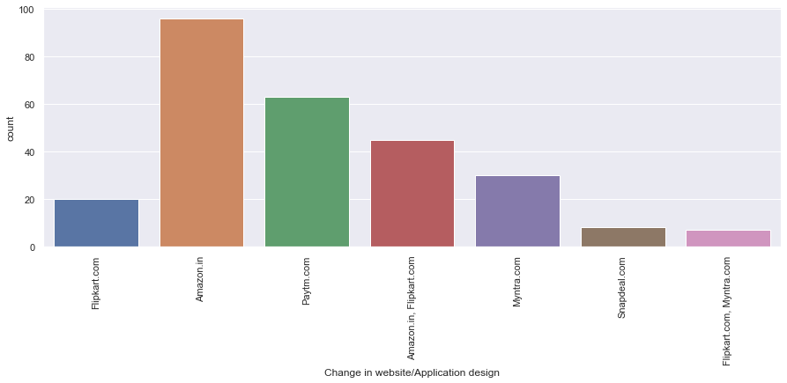

* Amazon.in does change in website/Application design most according to highest count (96) of online customers.

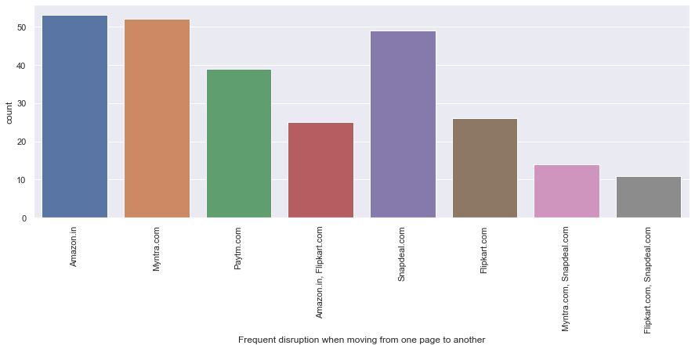

* The frequency of disruption while moving from one page to another is highest in Amazon.in according to highest count (53) of online customers.

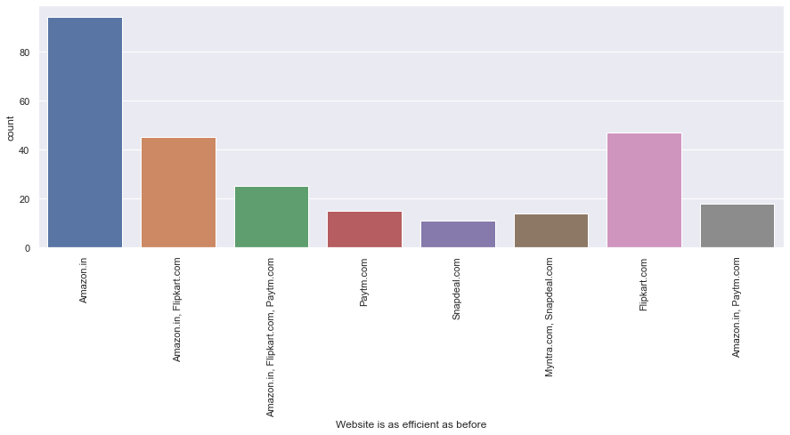

* Amazon.in, website is as efficient as before according to highest count (94) of online customers.

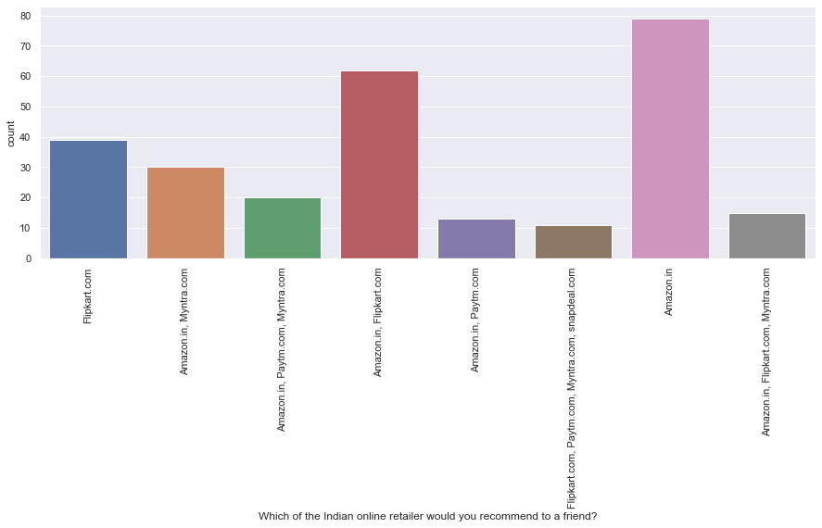

* Amazon.in is the Indian online retailer , that highest count of 79 people would recommend to their friends.
* **Bivariate Analysis:**

In this section we will check the relations between feature vs feature. For that we will check the relations between gender of the respondent with other features first.

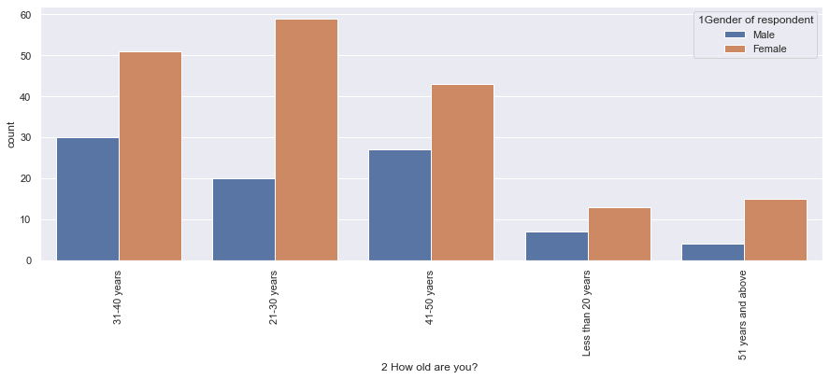

* female individuals of the age group 21-30 are involved in online shopping most. Female individuals of all the age groups are highly active than the male individuals in case of online shopping.

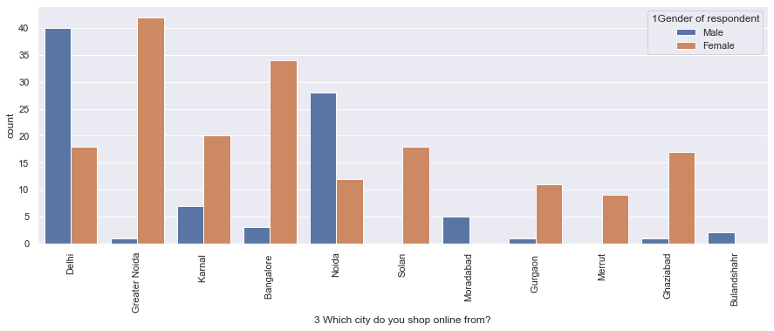

* Female individuals of Greater Noida are highest active in case of online shopping. Female individuals of Bangalore are 3rd highest active in case of online shopping. Male individuals from Delhi are 2nd highest active in case of online shopping.

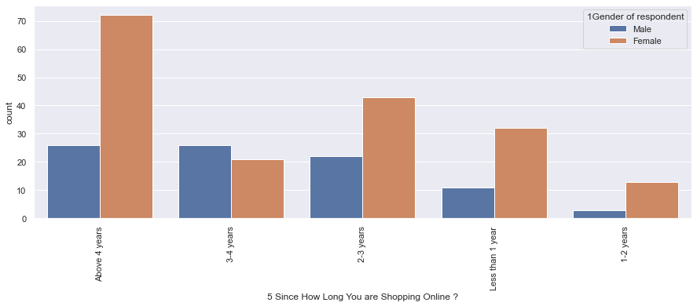

* Female individuals who are doing online shopping or using the e-retail apps since 4 years and above are highest in count.

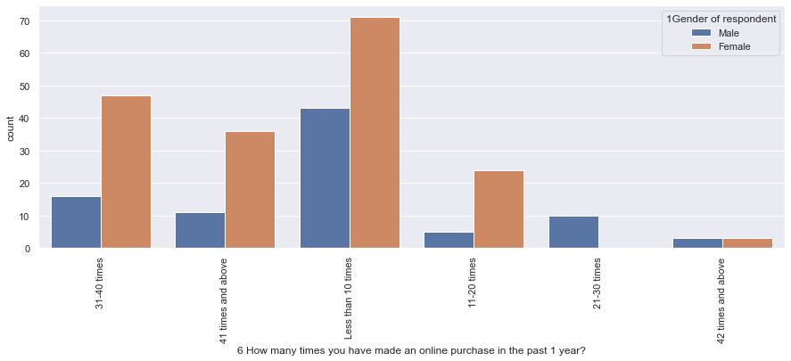

* Less than 10 times highest count of female individuals made online purchase in past 1 year.

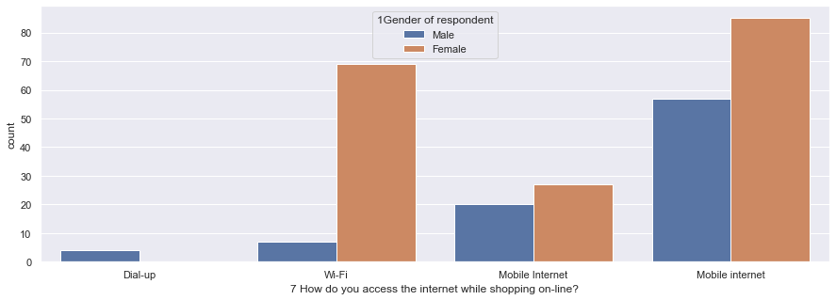

* Female individuals who are using mobile internet while doing online shopping are highest in number.

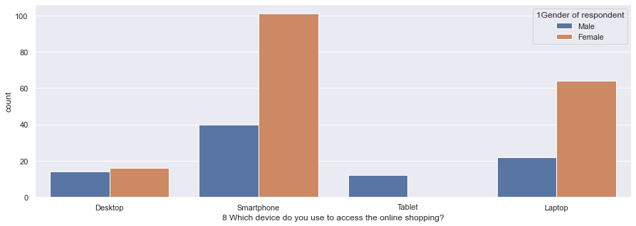

* Female individuals who are using smartphone while doing online shopping are highest in number.

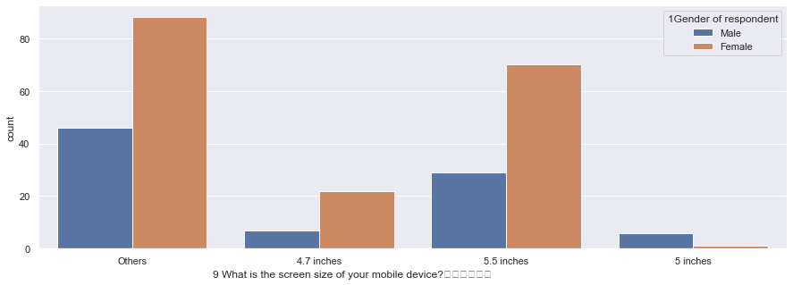

* Female individuals who are using screen size other than 4.7 inches, 5.5 inches, 5 inches while doing online shopping are highest in number.

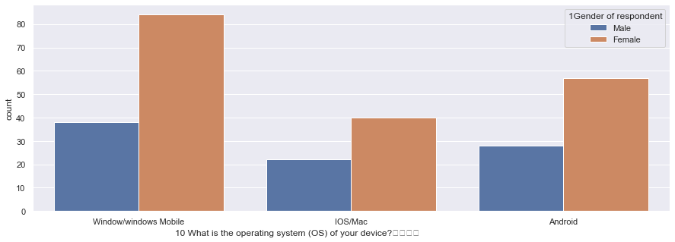

* Female individuals who are using window/windows mobile while doing online shopping are highest in number.

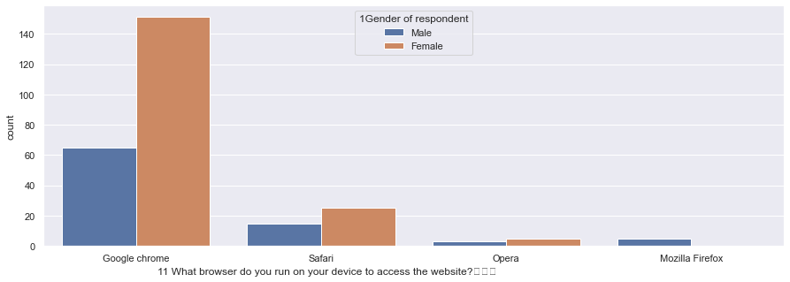

* Female individuals who are using Google chrome while accessing the website are highest in number.

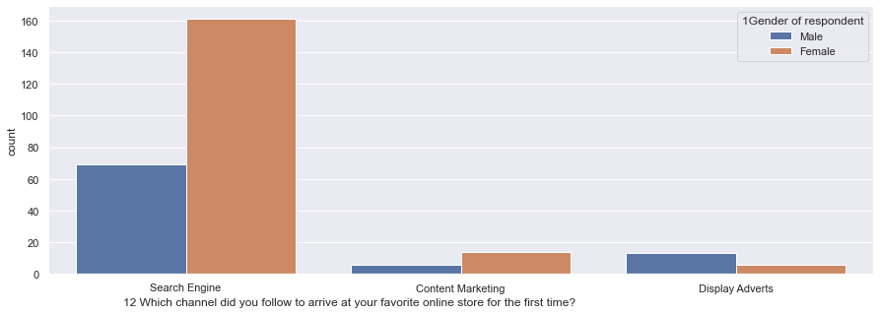

* Female individuals do follow Search engines to arrive at their favourite online store for the first time are highest in number.

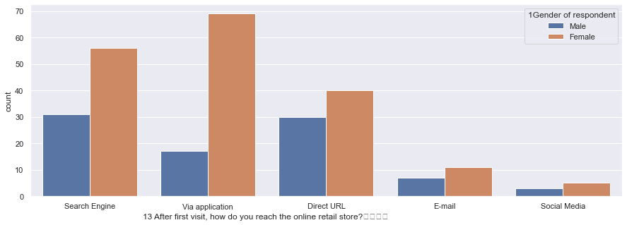

* Highest count of female individuals use applications to reach the online retail store after first visit.

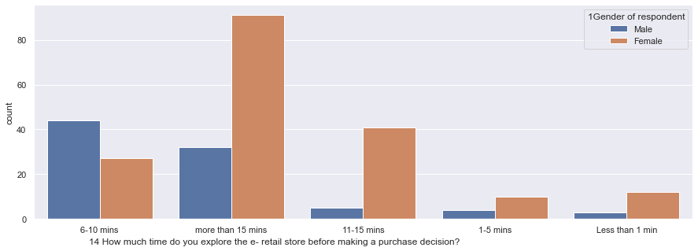

* Highest count of female individuals explore the e-retail store more than 15 minutes before making a purchase decision.

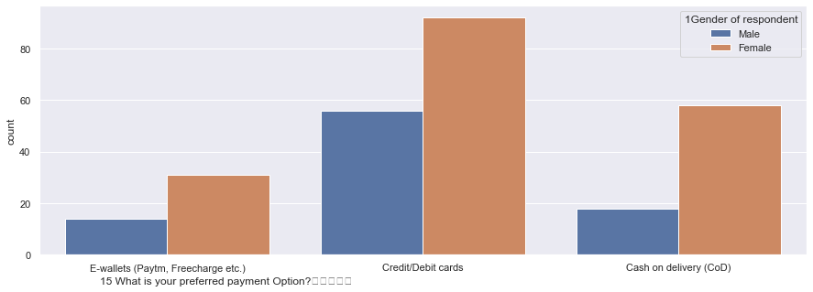

* Highest count of female individuals prefer credit/debit card payment option.

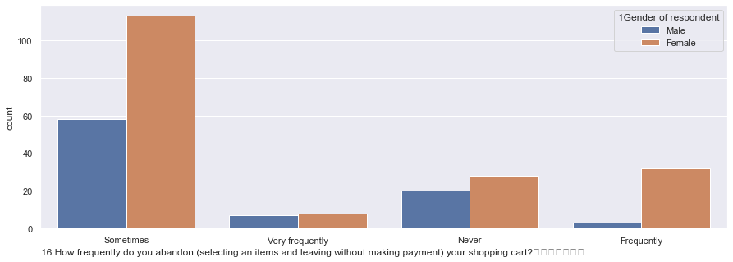

* Highest count of female individuals sometimes abandon (selecting an items and leaving without making payment) their shopping bag.

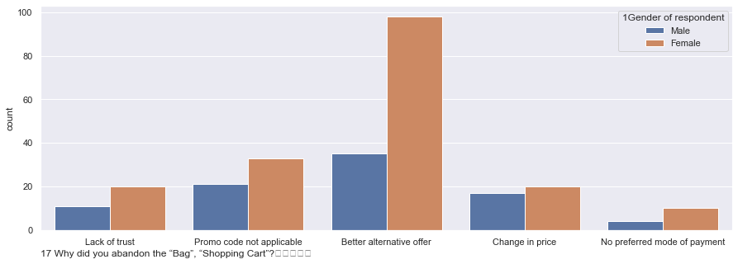

* Highest count of female individuals abandon their shopping bag because of better alternative offer.

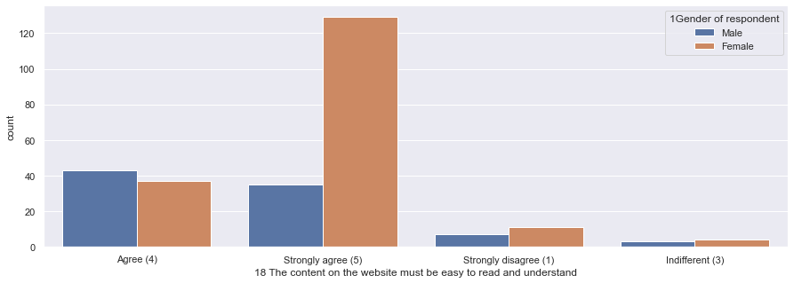

* Highest count of female individual are strongly agreed that the website must be easy to read and understand.

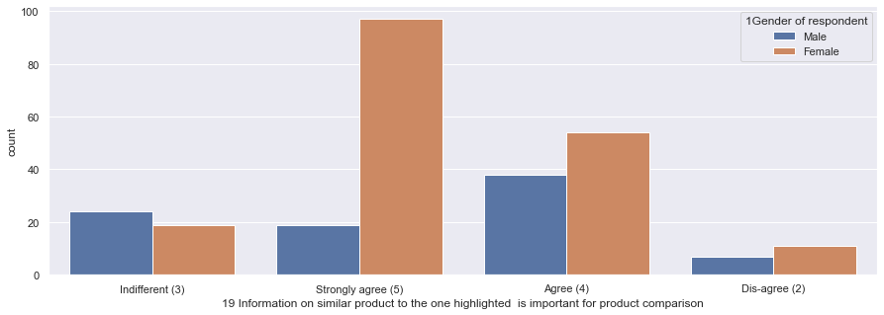

* Highest count of female individual are strongly agreed that information on similar product to the one highlighted is important for product comparison.

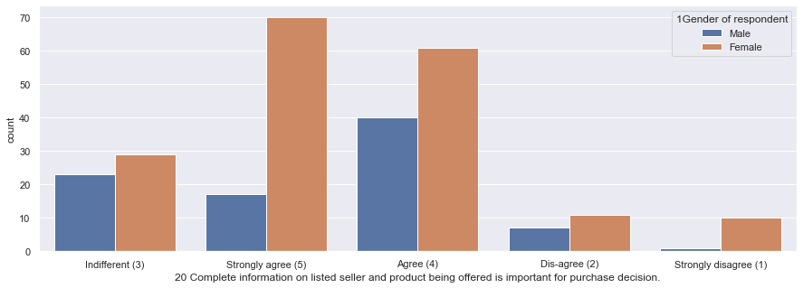

* Highest count of female individuals are strongly agreed that Complete information on listed seller and product being offered is important for purchase decision.

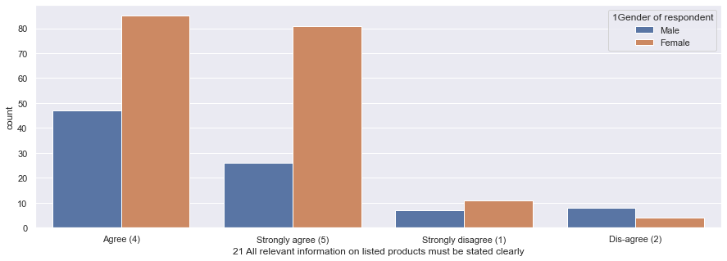

* Highest count of female individuals are agreed that All relevant information on listed products must be stated clearly.

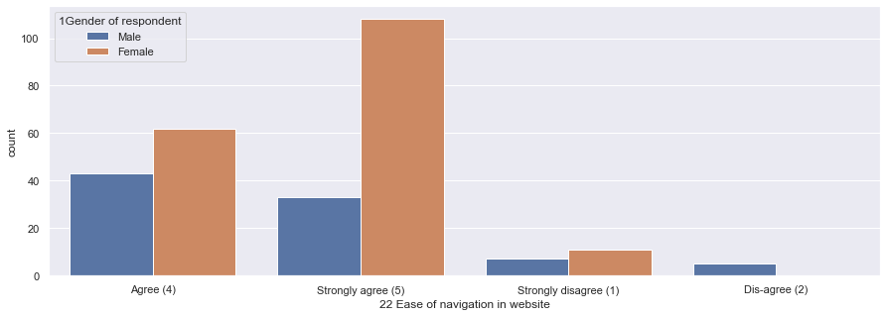

* Highest count of female individuals are strongly agreed that there is ease of navigation in website.

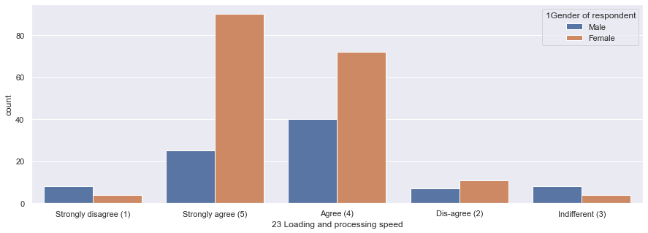

* Highest count of female individuals are strongly agreed that Loading and processing speed is important.

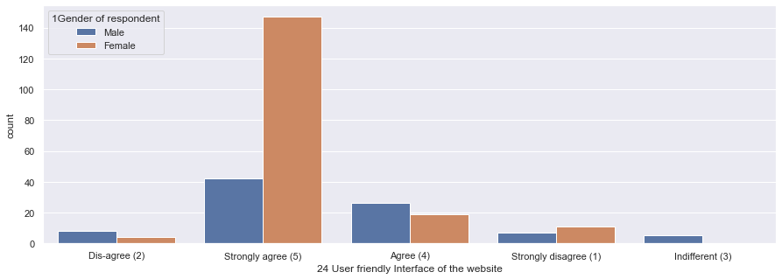

* Highest count of female individuals are strongly agreed that user friendly Interface of the website is important.

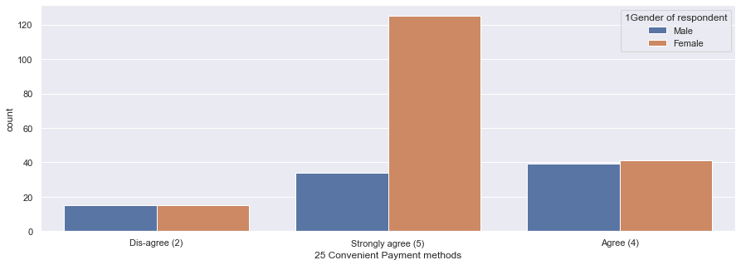

* Highest count of female individuals are strongly agreed that Convenient Payment methods is important.

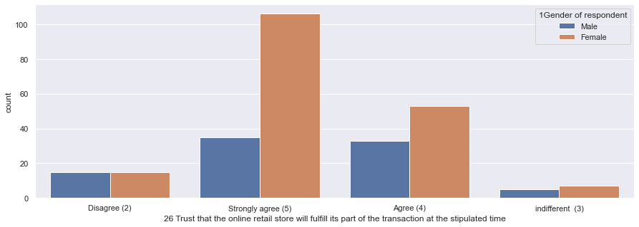

* Highest count of female individuals are strongly agreed that trust that the online retail store will fulfil its part of the transaction at the stipulated time.

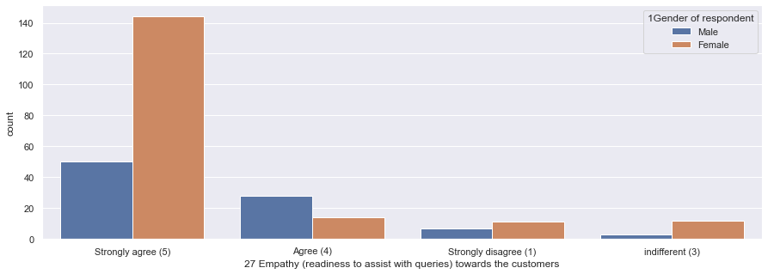

* Highest count of female individuals are strongly agreed that empathy (readiness to assist with queries) towards the customers is important.

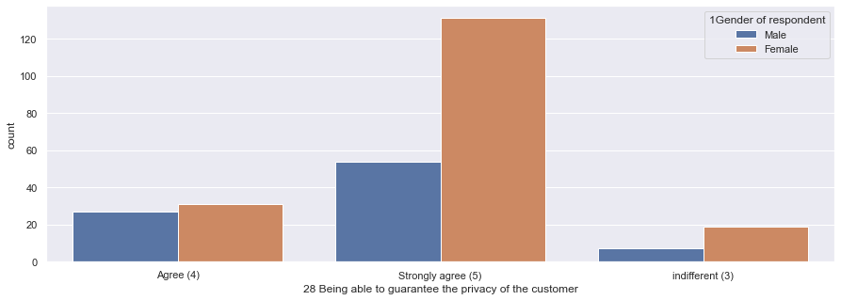

* Highest count of female individuals are strongly agreed that being able to guarantee the privacy of the customer is important.

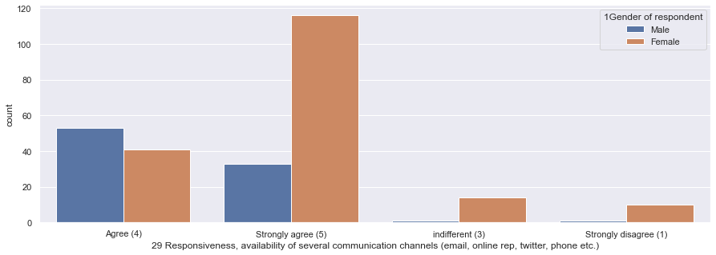

* Highest count of female individuals are strongly agreed that responsiveness, availability of several communication channels (email, online rep, twitter, phone etc.) is important.

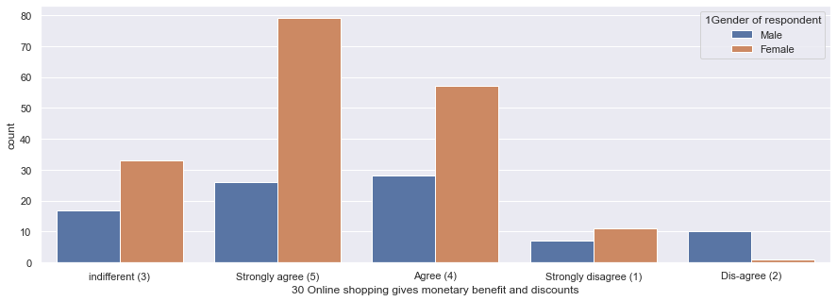

* Highest count of female individuals are strongly agreed that online shopping gives monetary benefit and discounts.

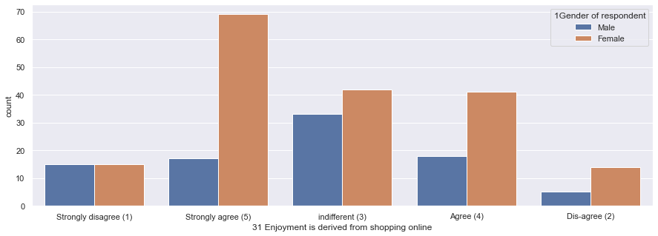

* Highest count of female individuals are strongly agreed that Enjoyment is derived from shopping online.

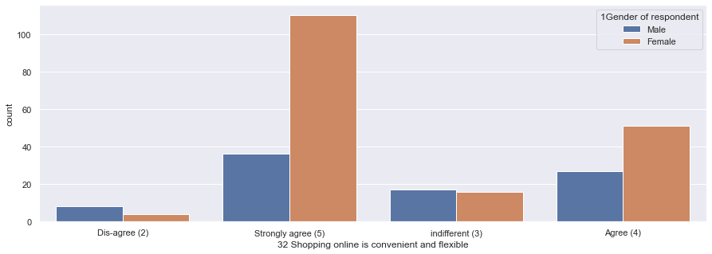

* Highest count of female individuals are strongly agreed that shopping online is convenient and flexible.

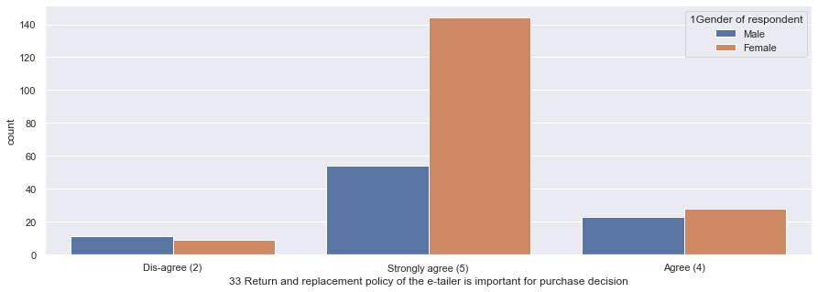

* Highest count of female individuals are strongly agreed that return and replacement policy of the e-tailer is important for purchase decision.

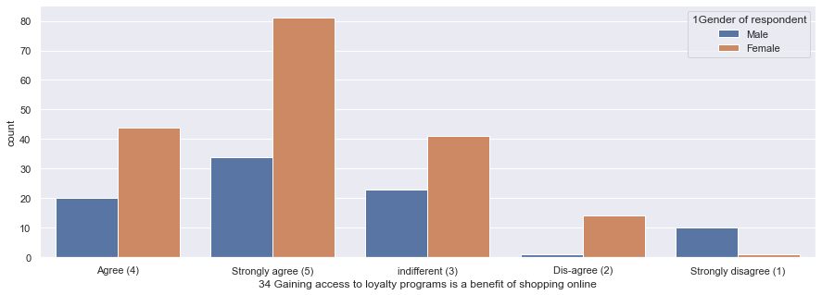

* Highest count of female individuals are strongly agreed that gaining access to loyalty programs is a benefit of shopping online.

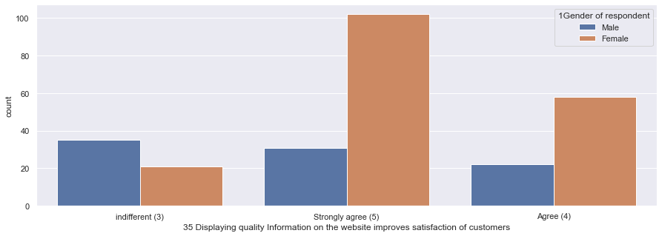

* Highest count of female individuals are strongly agreed that displaying quality Information on the website improves satisfaction of customers.

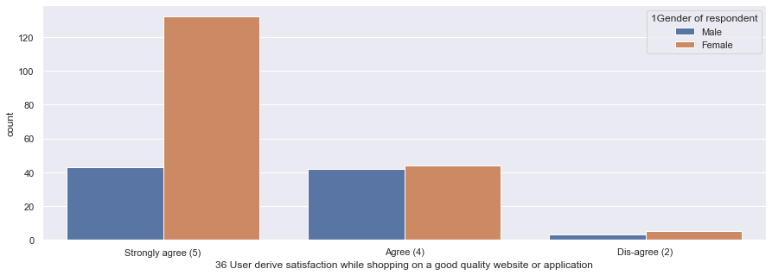

* Highest count of female individuals are strongly agreed that user derive satisfaction while shopping on a good quality website or application.

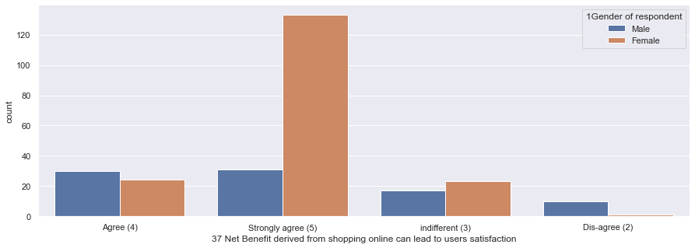

* Highest count of female individuals are strongly agreed that Net benefit derived from shopping online can lead to users satisfaction.

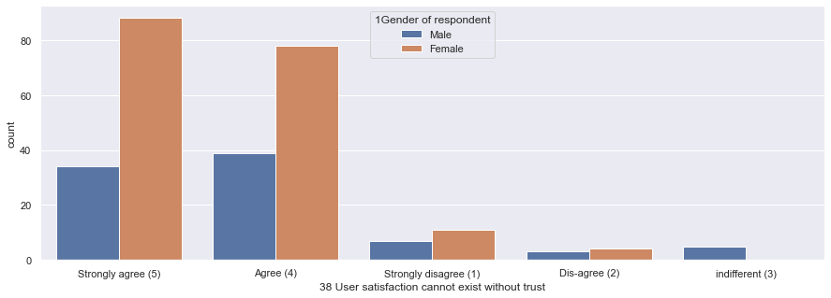

* Highest count of female individuals are strongly agreed that user satisfaction cannot exist without trust.

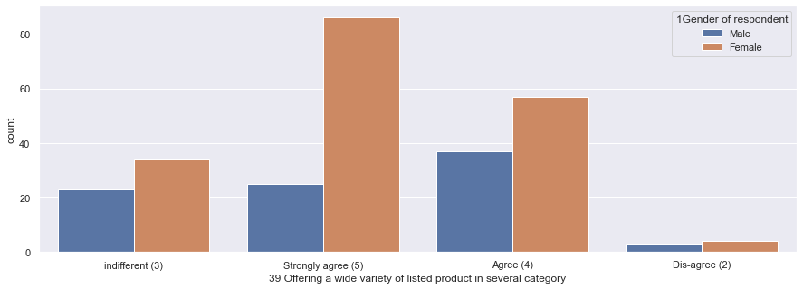

* Highest count of female individuals are strongly agreed that offering a wide variety of listed product in several category is important.

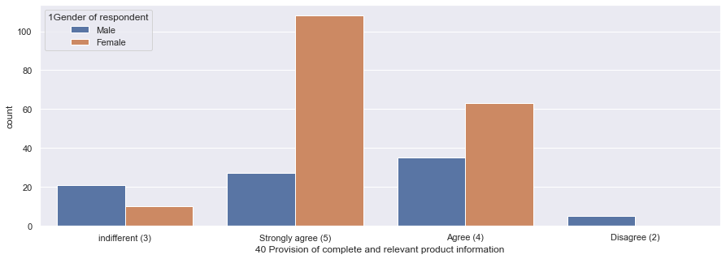

* Highest count of female individuals are strongly agreed that provision of complete and relevant product information is important.

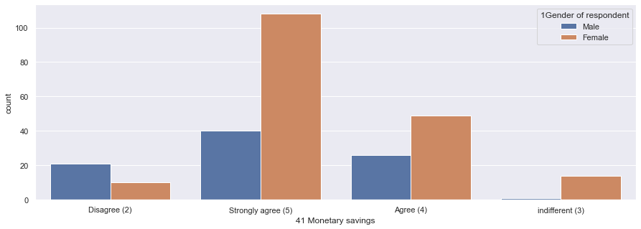

* Highest count of female individuals are strongly agreed that online shopping brings about monetary savings.

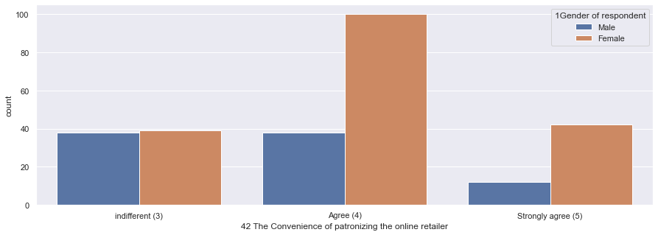

* Highest count of female individuals are agreed that the convenience of patronizing the online retailer is important.

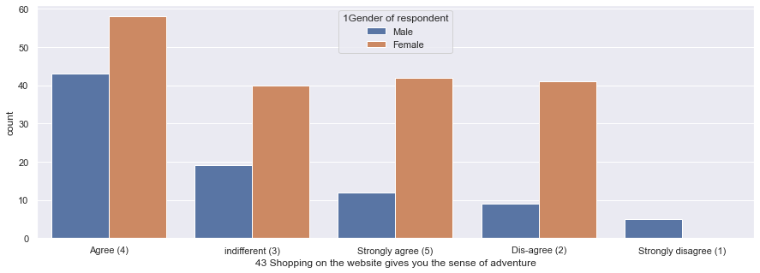

* Highest count of female individuals are agreed that shopping on the website gives you the sense of adventure.

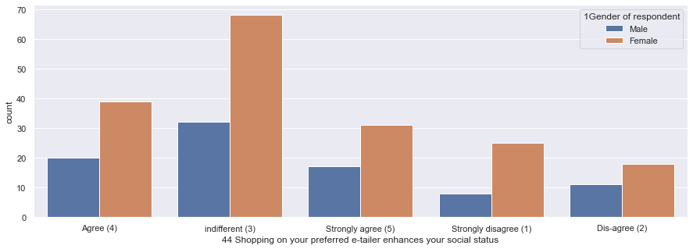

* Highest count of female individuals are indifferent that shopping on your preferred e-tailer enhances their social status.

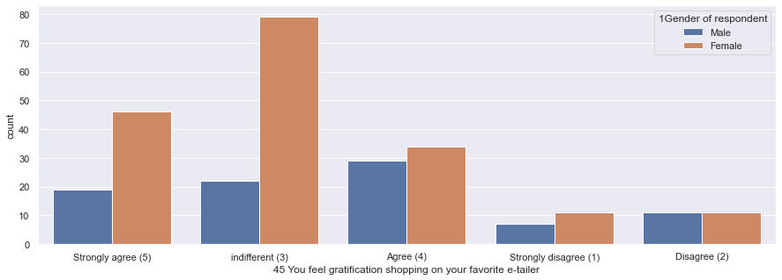

* Highest count of female individuals are indifferent about gratification shopping on their favourite e-tailer.

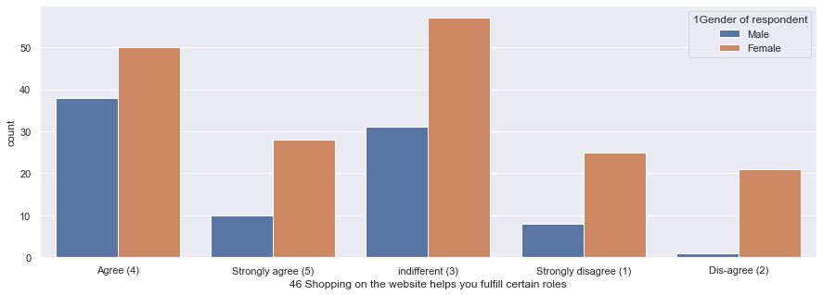

* Highest count of female individuals are indifferent about shopping on the website helps them fulfil certain roles.

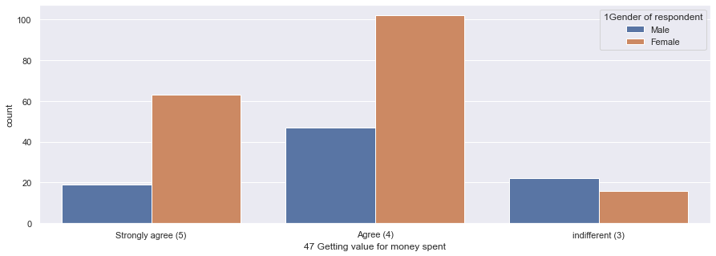

* Highest count of female individuals are agreed on getting value for money spent.

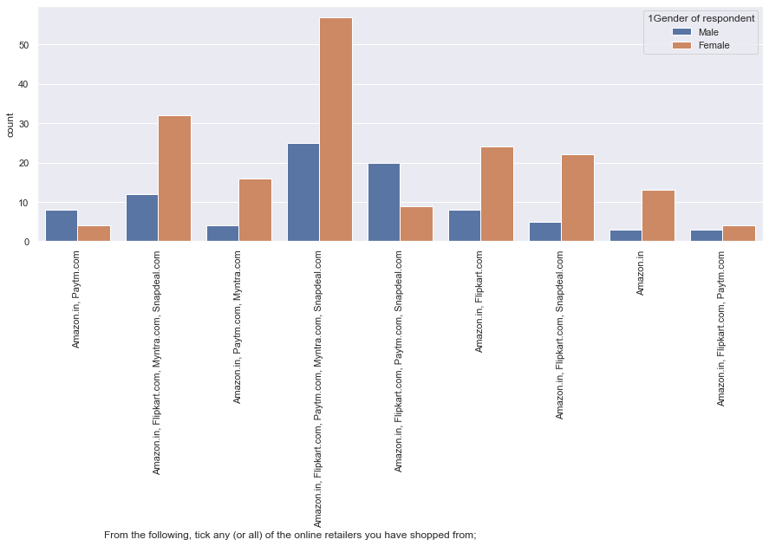

* Highest count of female individuals have shopped from Amazon.in, Flipkart.com, Paytm.com, Myntra.com, Snapdeal.com .

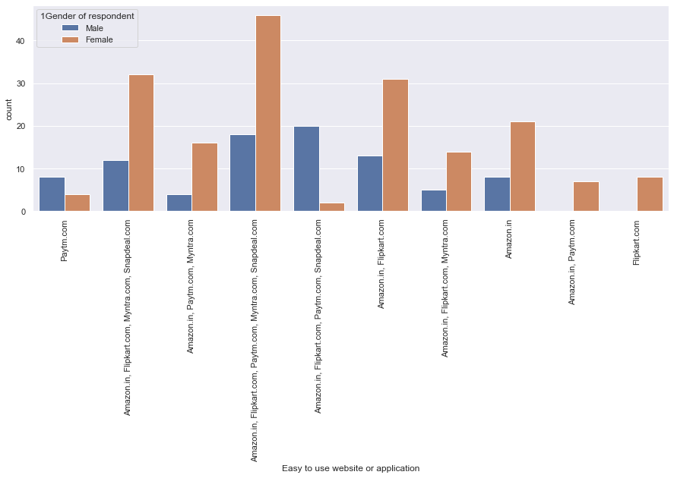

* Highest count of female individuals prefer Amazon.in, Flipkart.com, Paytm.com, Myntra.com, Snapdeal.com as these applications or websites are easy to use.

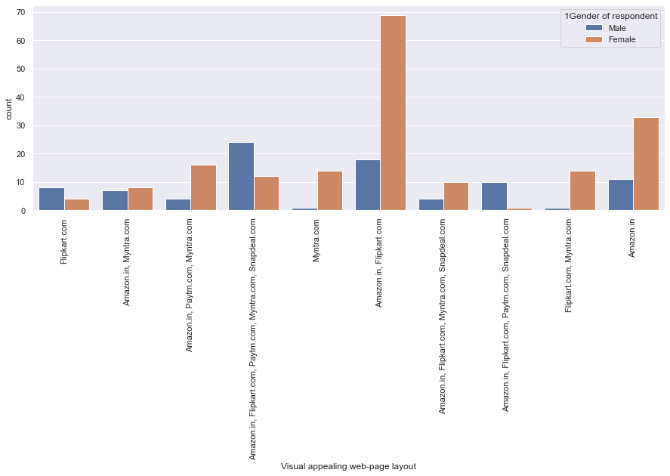

* Highest count of female individuals think Amazon.in, Flipkart.com are having visual appealing web-page layout.

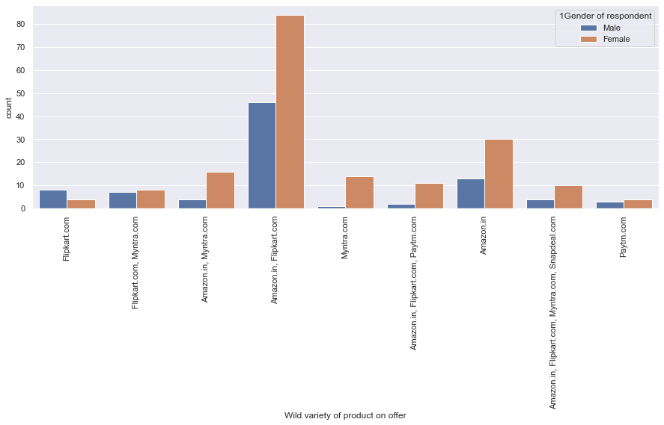

* Highest count of female individuals think Amazon.in, Flipkart.com are having wild variety of product on offer.

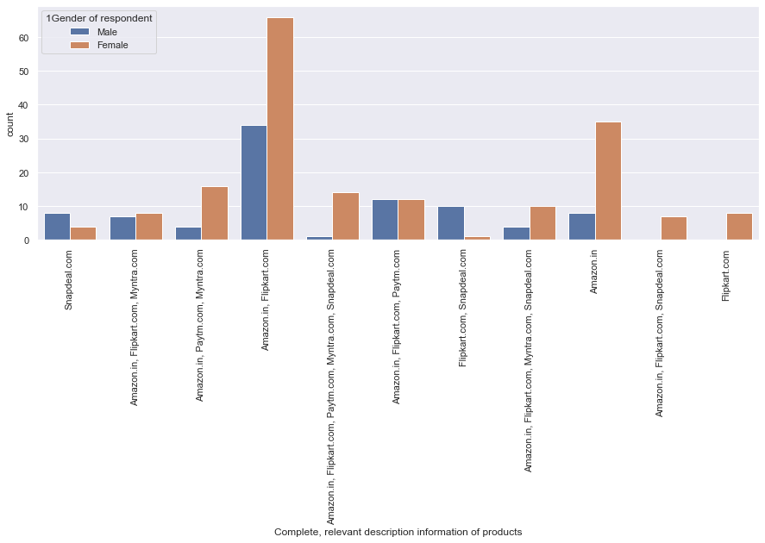

* Highest count of female individuals think Amazon.in, Flipkart.com are having complete, relevant description information of products.

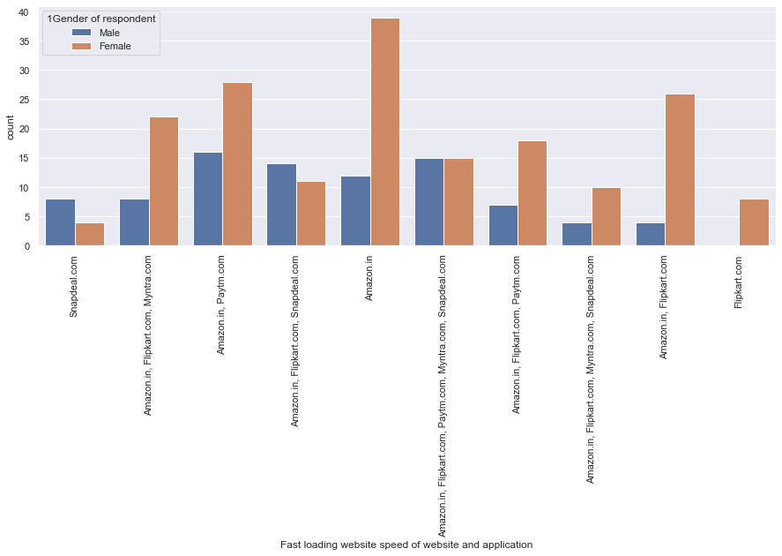

* Highest count of female individuals think Amazon.in is having fast loading website speed as an application and website.



* Highest count of female individuals rely on Amazon.in most.

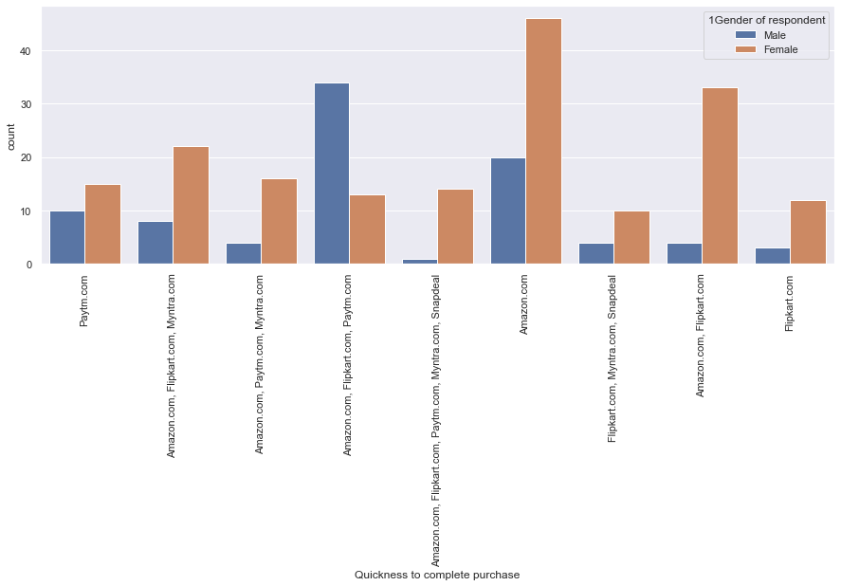

* Highest count of female individuals think Amazon.in is quickest to complete purchase.

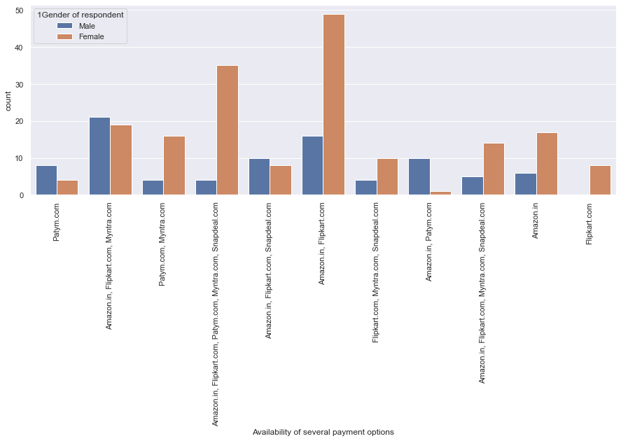

* Highest count of female individuals prefer Amazon.in, flipkart.com as availability of several payment options.

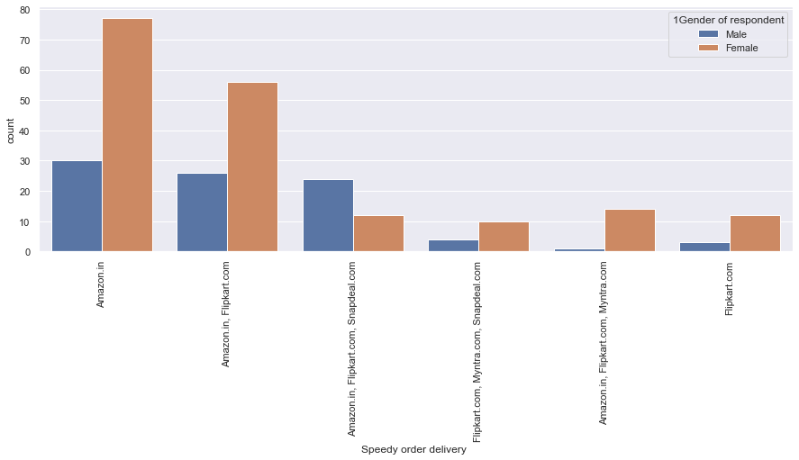

* Highest count of female individuals prefer Amazon.in because of speedy order delivery.

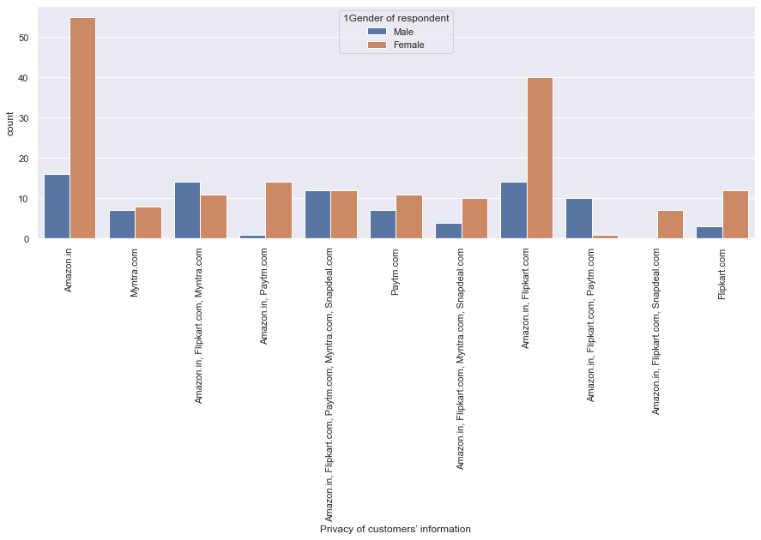

* Highest count of female individuals prefer Amazon.in because of privacy of customers’ information.

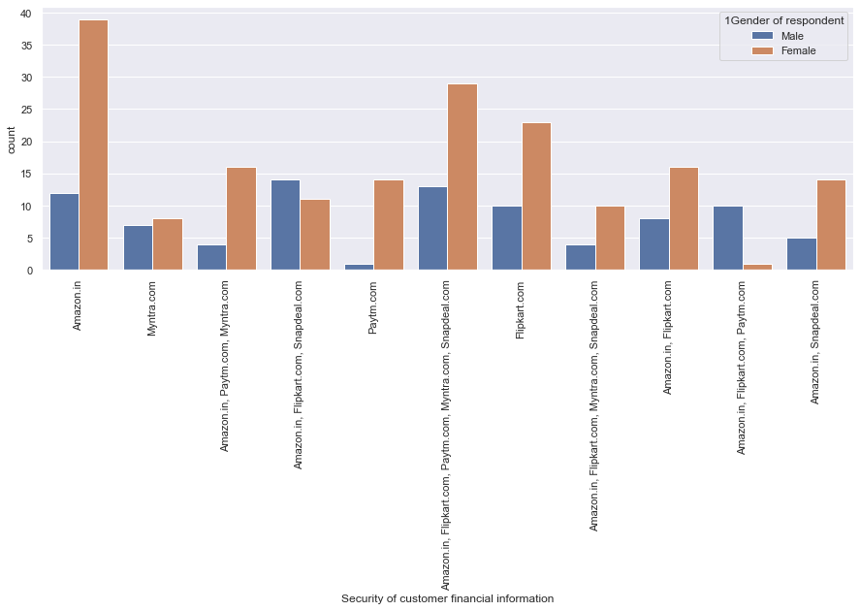

* Highest count of female individuals prefer Amazon.in because of security of customer financial information.

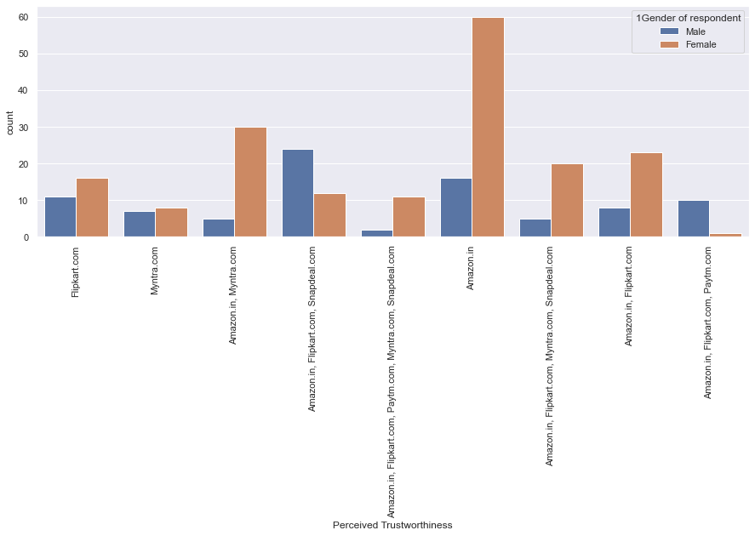

* Highest count of female individuals prefer Amazon.in because of perceived trustworthiness.

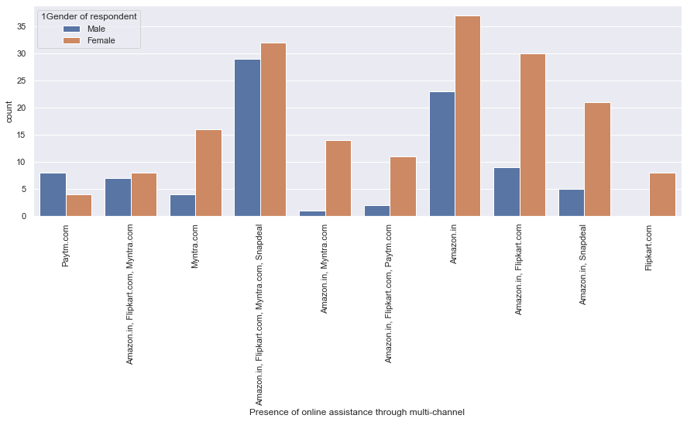

* Highest count of female individuals prefer Amazon.in because of the presence of online assistance through multi-channel.

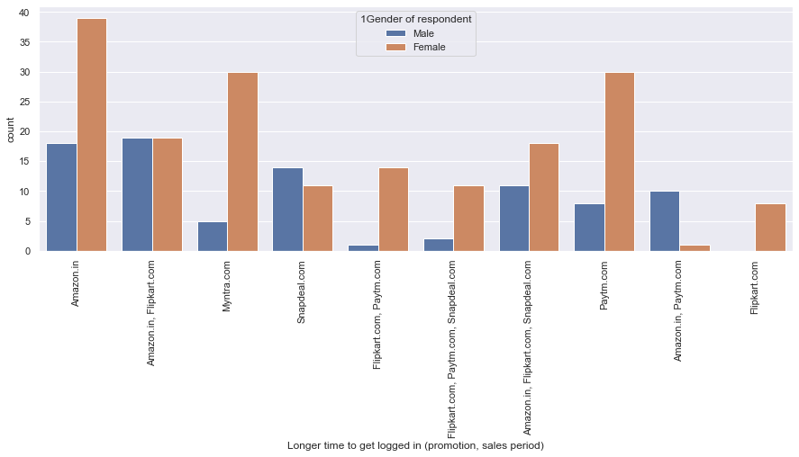

* Highest count of female individuals think Amazon.in take longer time to get logged in (promotion, sales period).

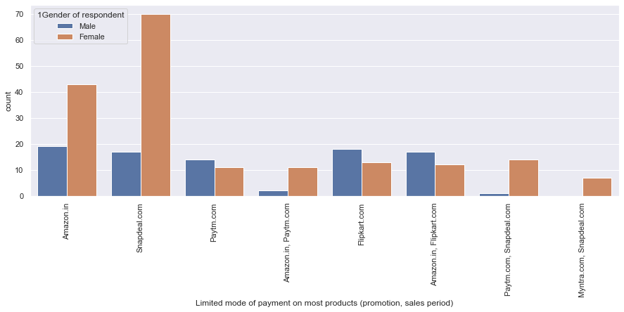

* Highest count of female individuals think Snapdeal.com shows limited mode of payment on most products (promotion, sales period).

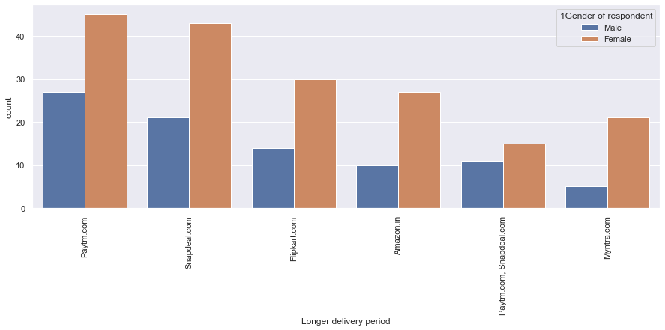

* Highest count of female individuals think Paytm.com takes longer delivery period.

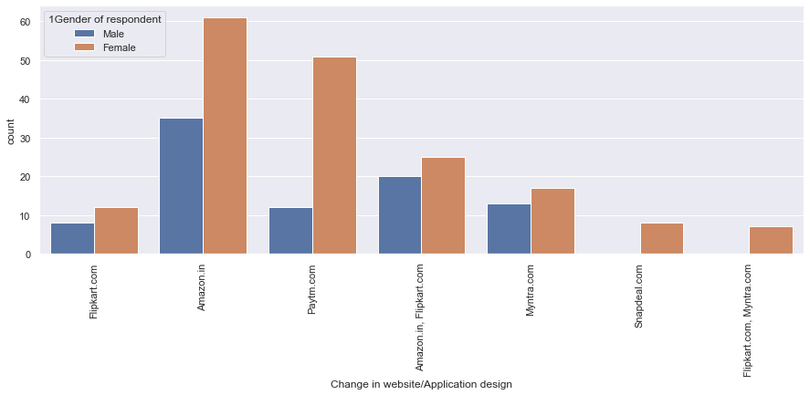

* Highest count of female individuals think Amazon.in changes its website/Application design frequently.

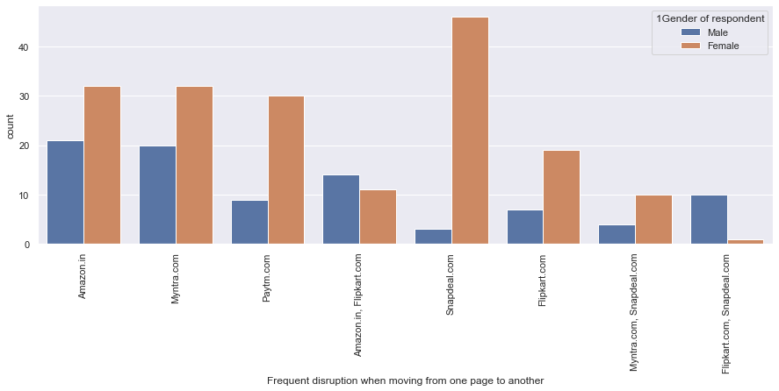

* Highest count of female individuals think in Snapdeal.com frequently disruption happens while moving from one page to another.

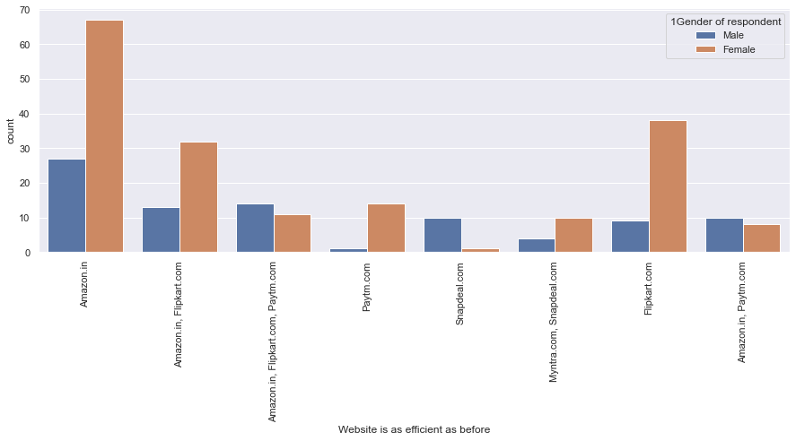

* Highest count of female individuals think Amazon.in website is as efficient as before.

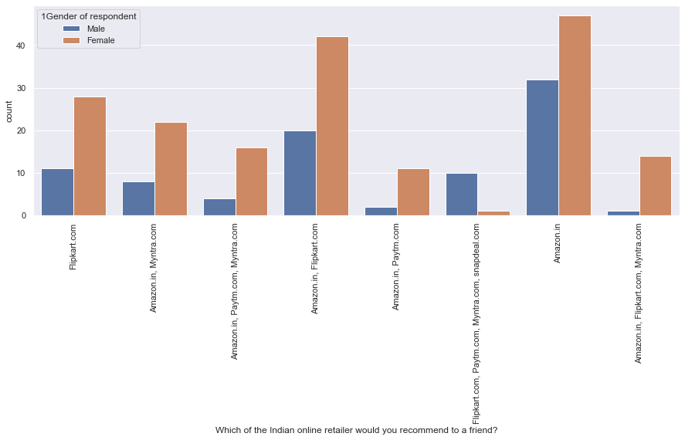

* Highest count of female individuals think in Amazon.in is the Indian online retailer that they would recommend to a friend.
* Relations between different variables and from which city customer do online shopping.

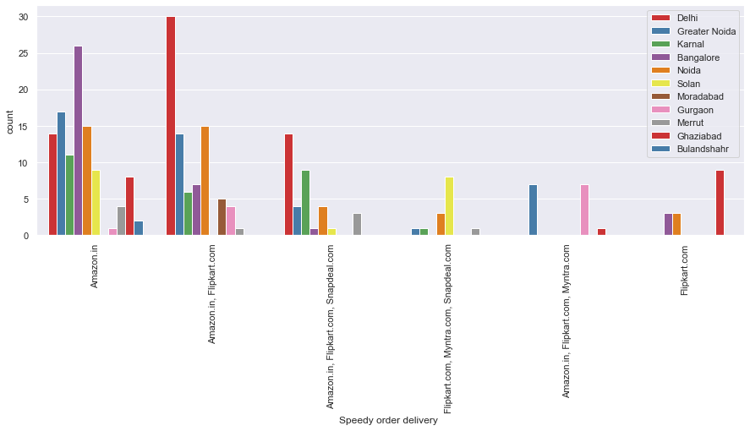

* In Delhi, Amazon.in, Flipkart.com do highest speedy order delivery.

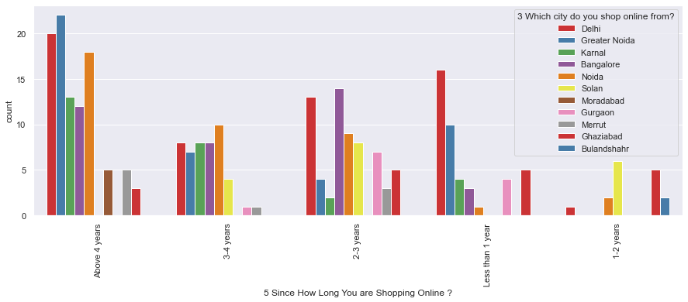

* Highest count of people from Greater Noida are doing online shopping since 4 years and above.

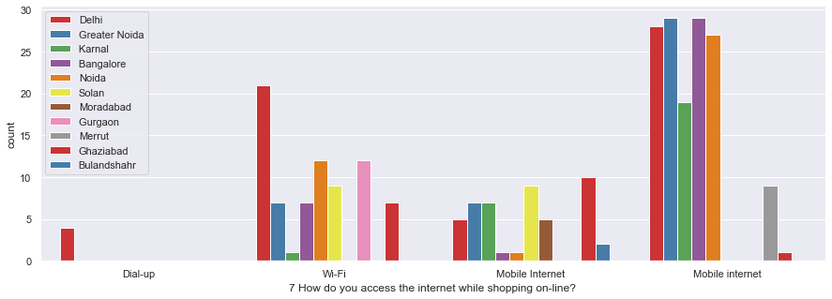

* Highest count of people from Greater Noida and Bangalore use mobile internet while shopping online.

.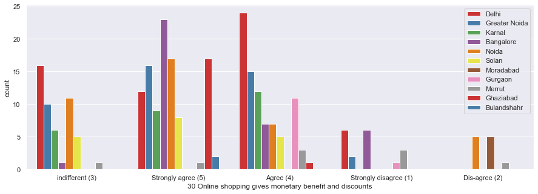

* Highest count of people from Delhi strongly agree that Online shopping gives monetary benefit and discounts.

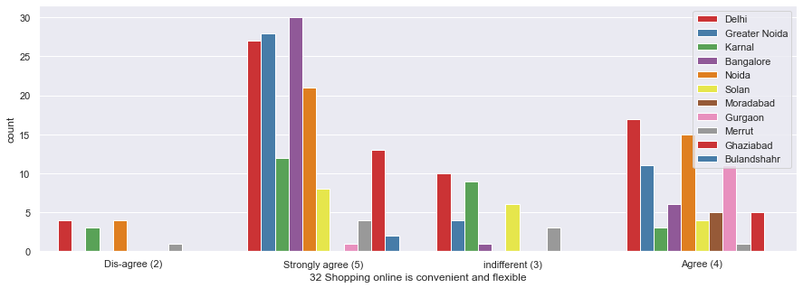

* Highest count of people from Bangalore strongly agree that shopping online is convenient and flexible.

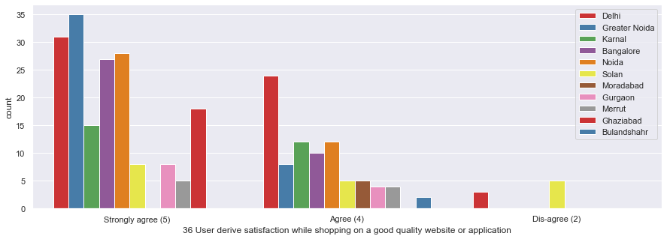

* Highest count of people from Greater Noida strongly agree with, user derive satisfaction while shopping on a good quality website or application.

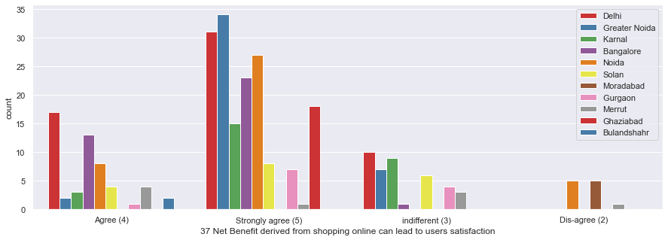

* Highest count of people from Greater Noida strongly agree with, Net benefit derived from shopping online can lead to users satisfaction.

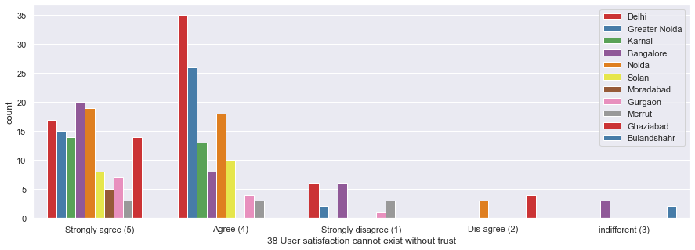

* Highest count of people from Delhi agree with, user satisfaction cannot exist without trust.

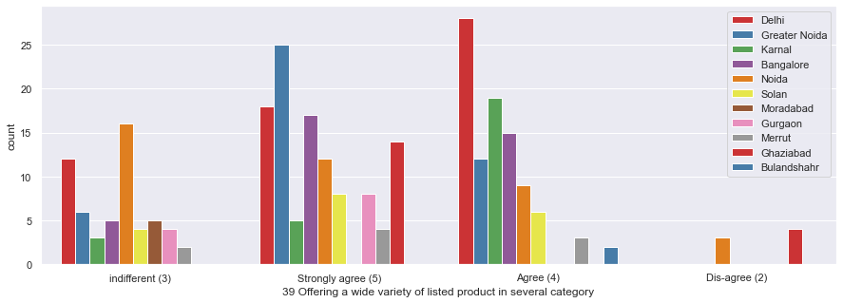

* Highest count of people from Delhi agree with, these online retailers are offering a wide variety of listed product in several category.

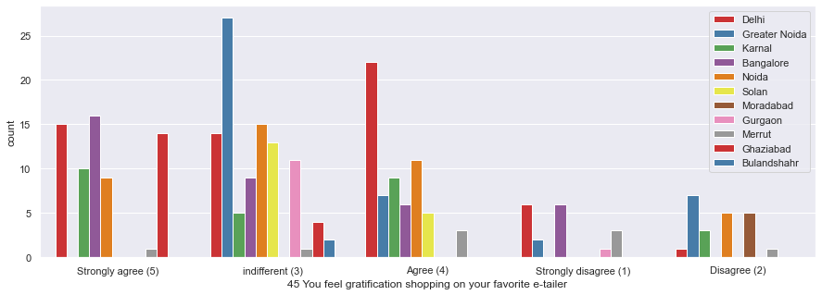

* Highest count of people from Greater Noida indifferent about, gratification shopping on their favourite e-tailer.

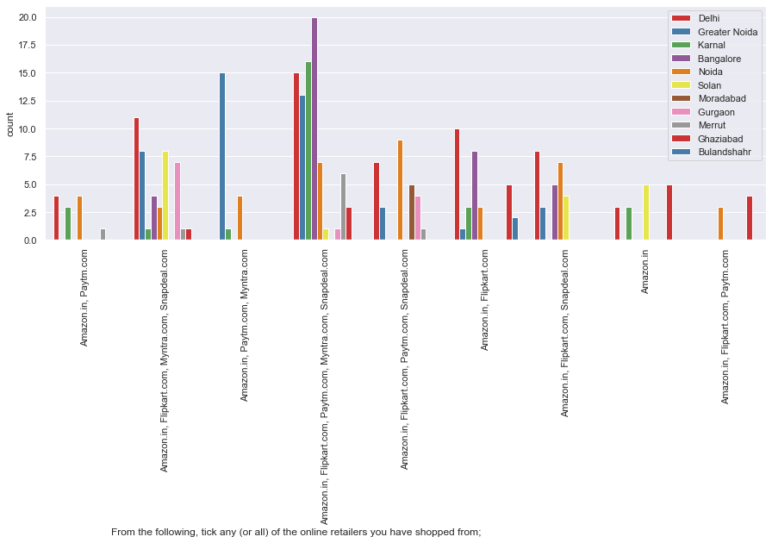

* Highest count of people from Bangalore mostly do online shopping from Anazon.in, Flipkart.com, Paytm.com, Myntra.com, Snapdeal.com.

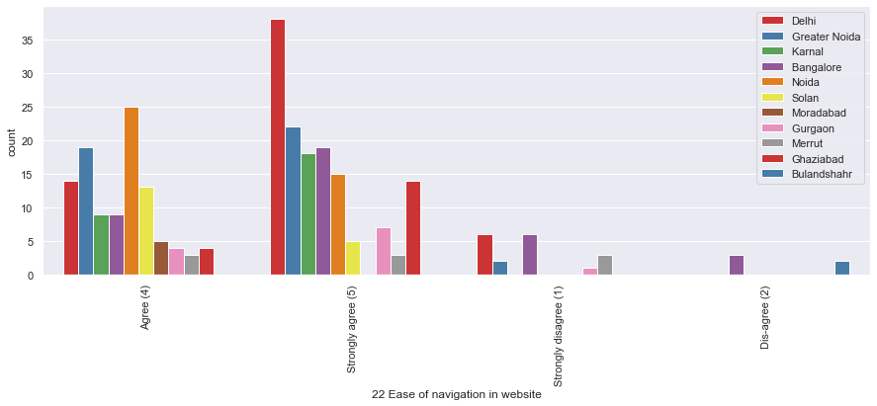

* Highest count of people from Delhi strongly agree that Ease of navigation in website is important.

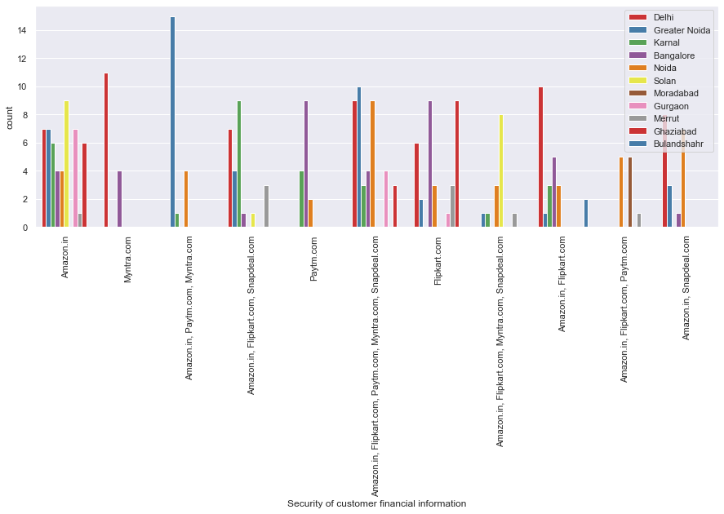

* Highest count of people from Greater Noida think Amazon.in, Paytm.com, Myntra.com take care the security of customer financial information.

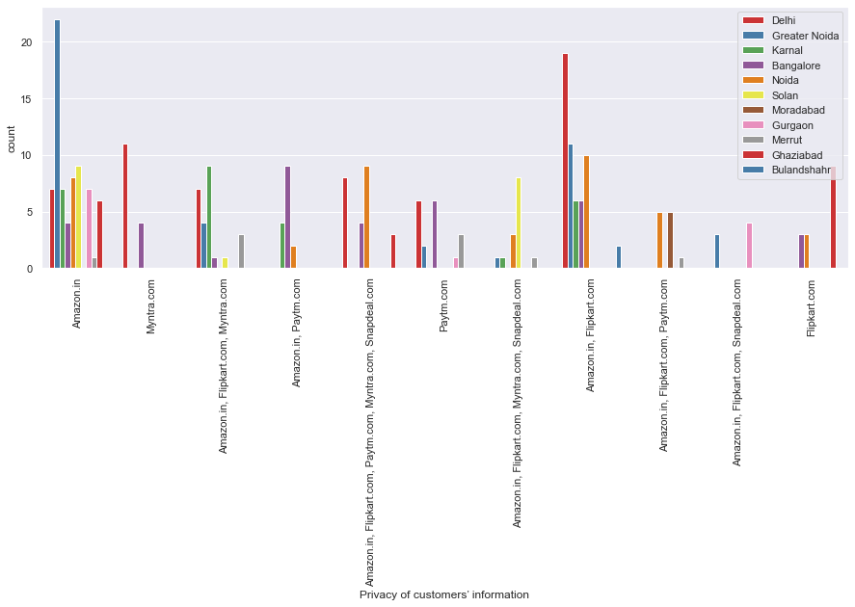

* Highest count of people from Delhi think Amazon.in, Flipkart.com take care the privacy of customers’ information.

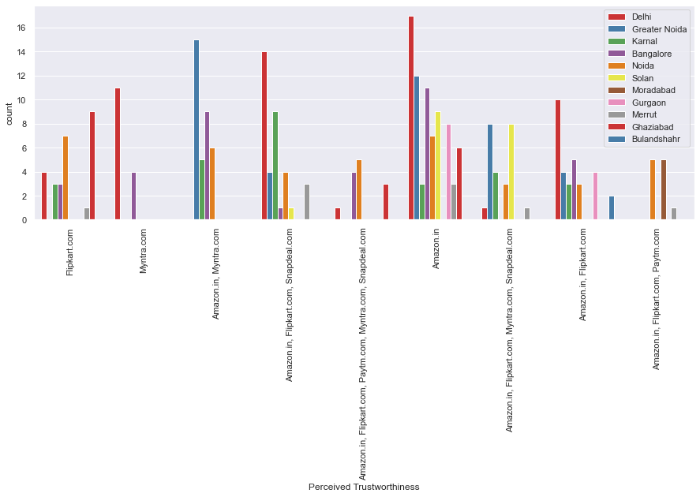

* Highest count of people from Delhi think Amazon.in perceived trustworthiness.

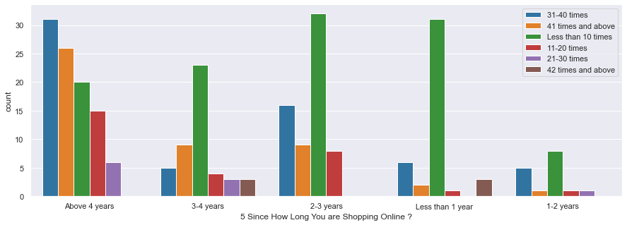

* Highest count of people who have made less than 10 times online purchase in the past 1 year are doing online shopping since 2-3 years.

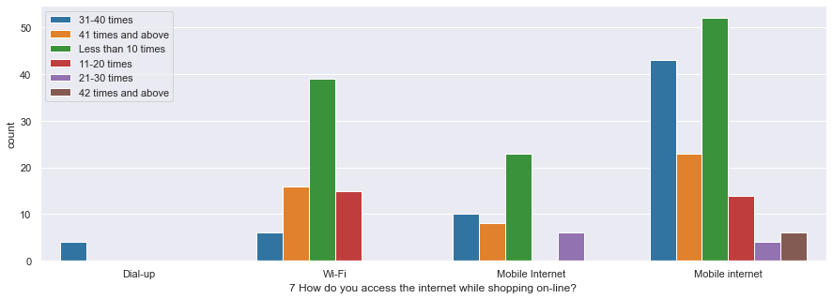

* Highest count of people who have made less than 10 times online purchase in the past 1 year, access internet through mobile internet.

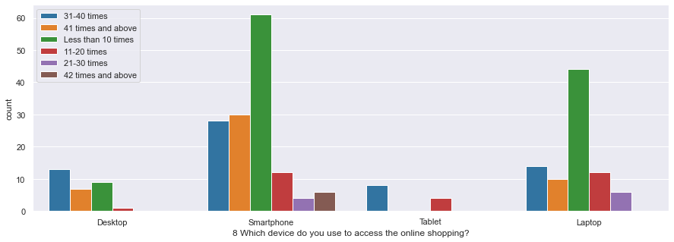

* Highest count of people who have made less than 10 times online purchase in the past 1 year, use smartphones to shop online.

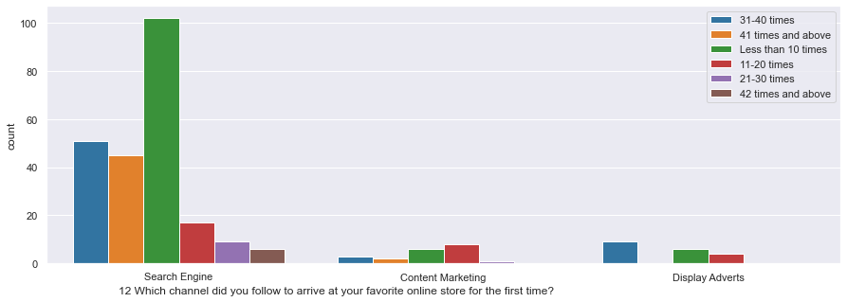

* Highest count of people who have made less than 10 times online purchase in the past 1 year, follow Search Engines to arrive at their favourite online store for the first time.

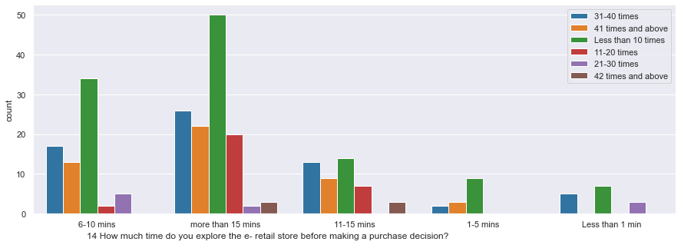

* Highest count of people who have made less than 10 times online purchase in the past 1 year, explore the e-retail store more than 15 minutes before making a purchase decision.

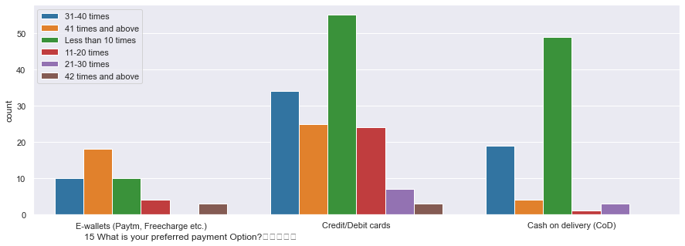

* Customers who have made an online purchase less than 10 times in the past 1 year prefer debit or credit cards as payment option.

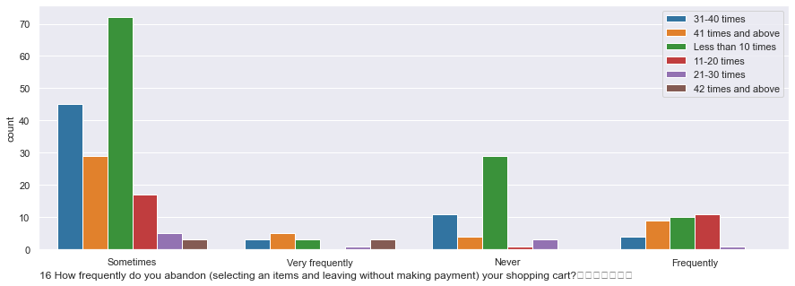

* Customers who have made an online purchase less than 10 times in the past 1 year prefer to visit the portal sometimes and abandon the selected item and leave without purchase.

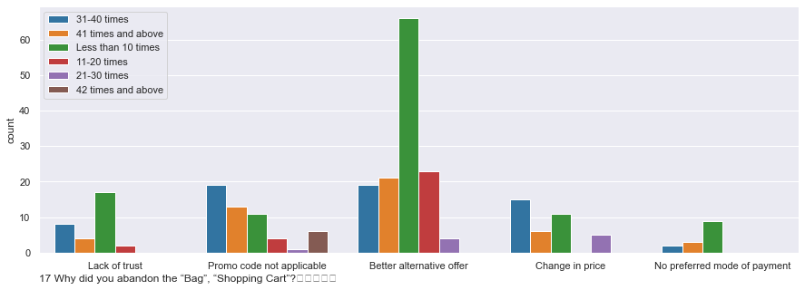

* Highest count of customers who have purchased less than 10 times in past 1 year, They abandon the shopping bag for better alternative offer.

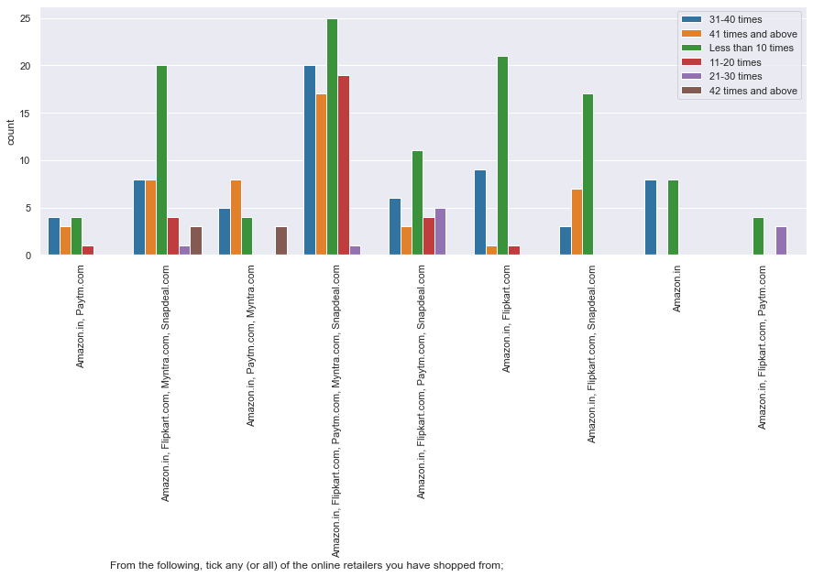

* Highest count of customers who have purchased less than 10 times in past 1 year, they mainly shopped from Amazon.in, Flipkart.com, Paytm.com, Myntra.com, Snapdeal.com .

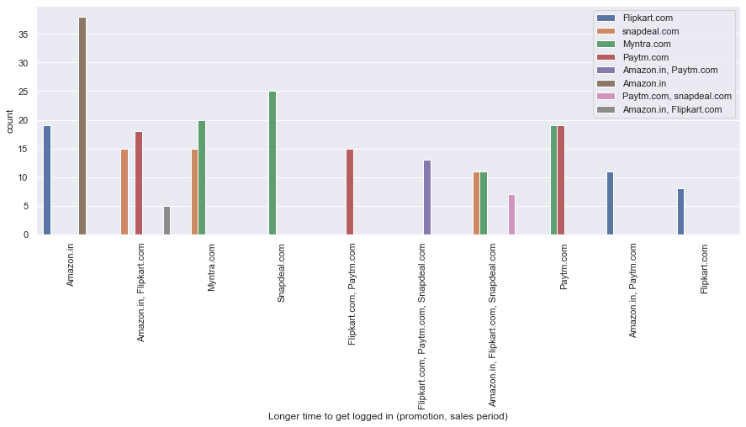

* Amazon.in takes longest time to get logged in (promotion, sales period) and it's also declare the price (promotion, sales period) latest.

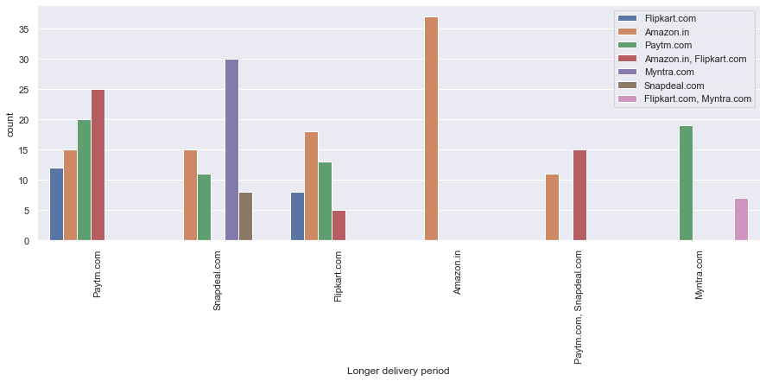

* Amazon.in takes longest time to delivery and it's also changes its website/Application design frequently.

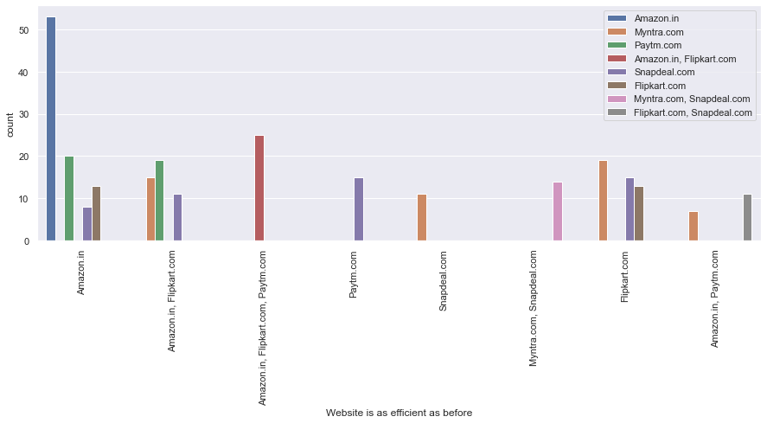

* Amazon.in is as efficient as before and in this app there is disruption when moving from one page to another.

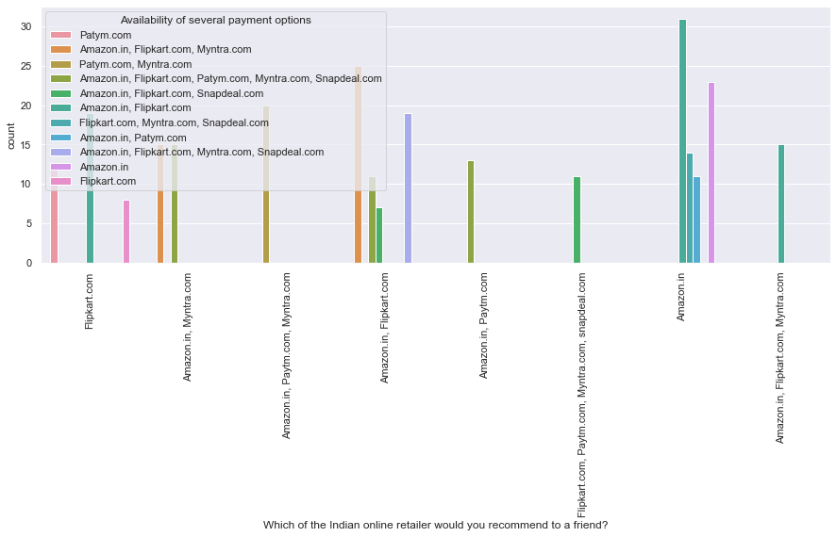

* Depending upon availability of several payment options, highest count of people recommend Amazon.in to their friends.

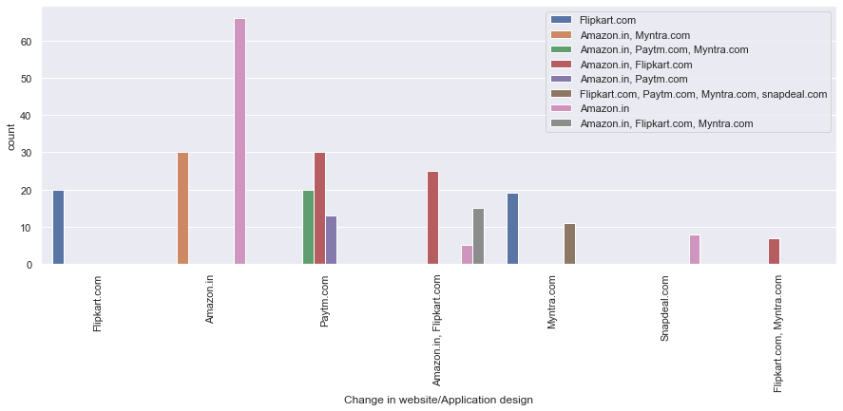

* Depending upon frequency of changing the website design, highest count of people will recommend Amazon.in to their friends.

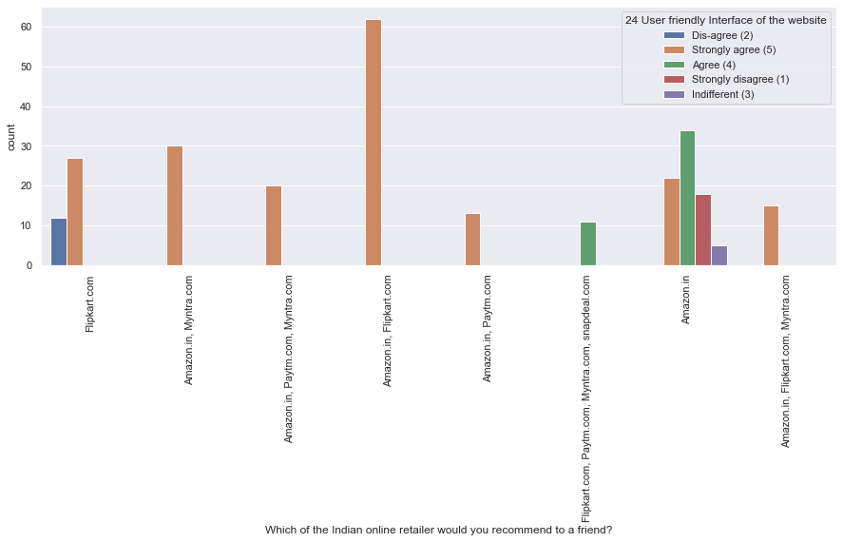

* Depending upon user friendly interface of the website, highest count of people strongly agreed that Amazon.in, Flipkart.com have got better interface than the rest and recommend these two websites to their friends.
* **Relations between Trust and online portals:**

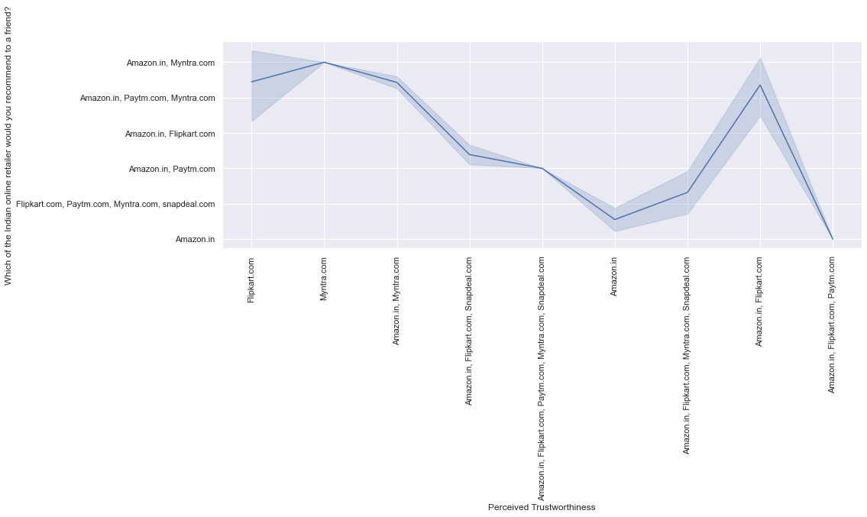

* Depending upon perceived trustworthiness, Highest count people recommend Amazon.in, Myntra.com to their friends.

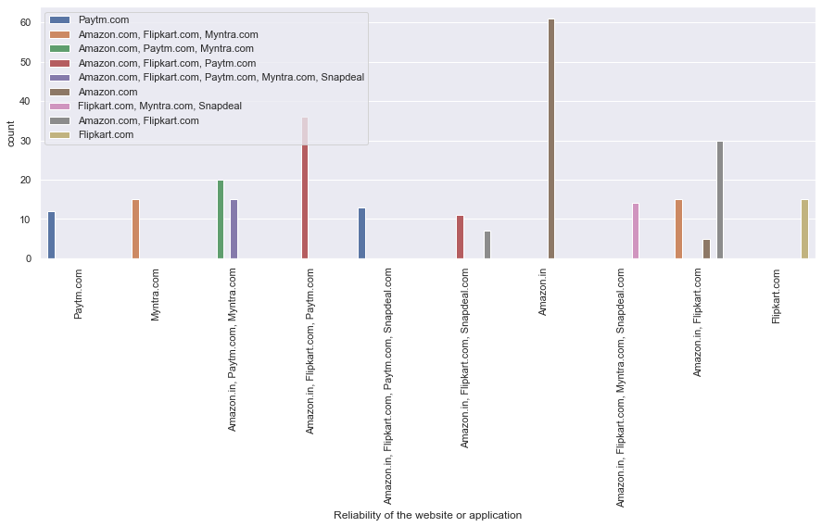

* Depending upon reliability of the website, highest count people recommend Amazon.in to their friends.

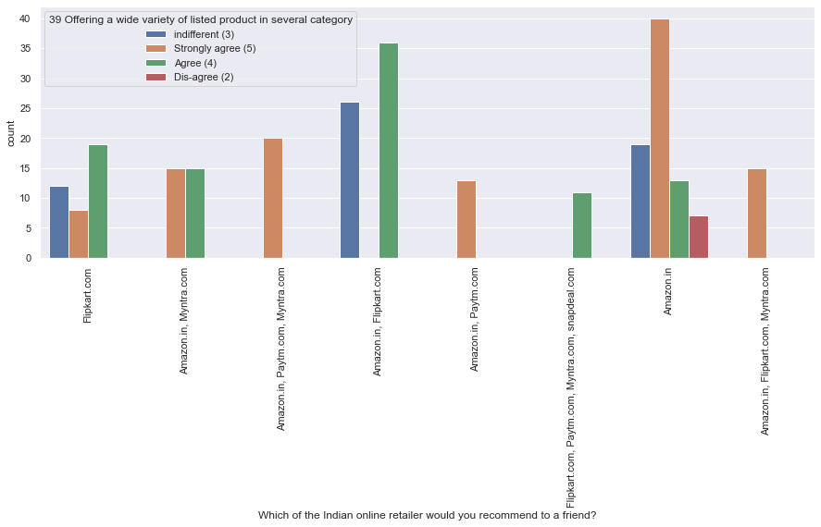

* Depending upon offering a wide variety of listed product in several category, Highest count people strongly agree and recommend Amazon.in to their friends.

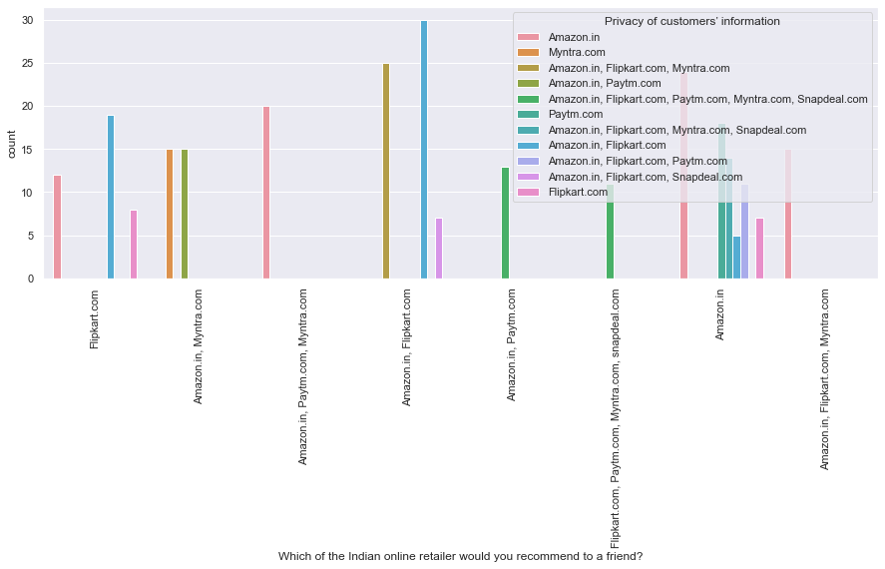

* Depending upon privacy of customers’ information, Highest count people recommend Amazon.in, Flipkart.com to their friends.

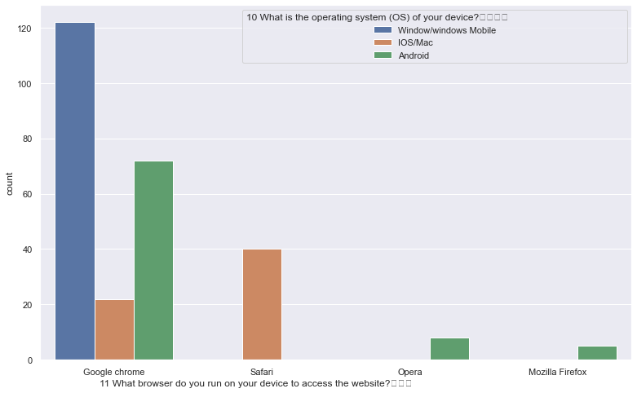

* Highest count of people use Google Chrome browser through window/windows mobile to do online shopping.

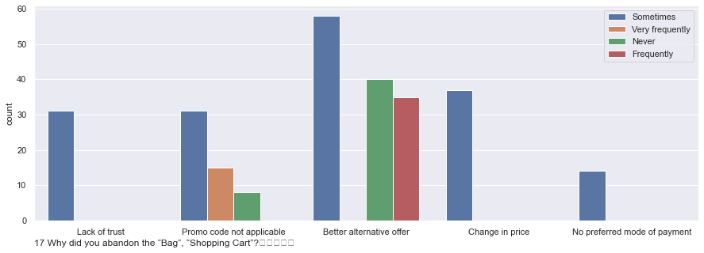

* Highest count of people sometimes abandon the shopping cart for better alternative offer.

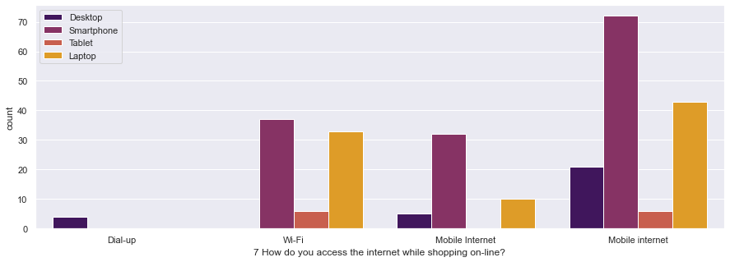

* Highest count of people use smartphones with mobile internet to shop online.

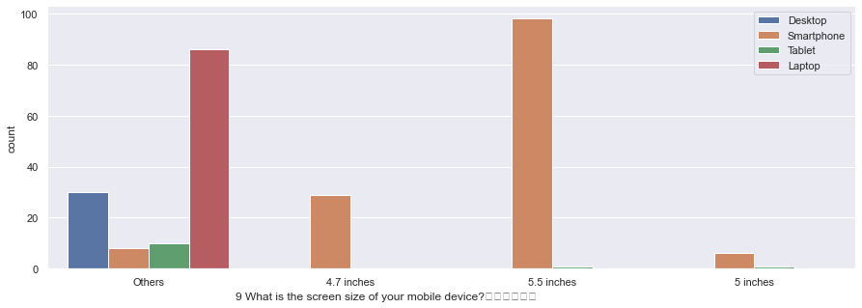

* Highest count of people use smartphones with 5.5 inches screen for doing online shopping. Laptops are also being used by good number of people and it's obvious the screen size is bigger, so that it categorized as other category.

**Multivariate Analysis:**

It is the technique used for analysis of multiple variables. Let’s check some of the relations.

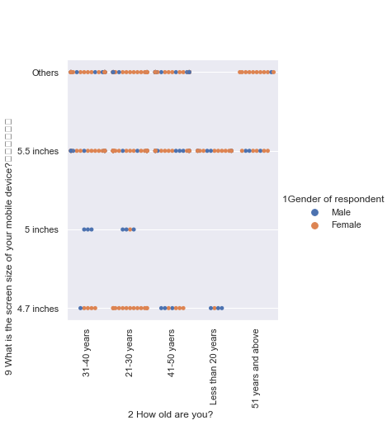

* Highest count of female individuals 21-30 years use 5.5 and 4.7 inches screen of smart phones to do online shopping. Male individuals from 31-40 mainly use 5 inches phones to do online shopping.

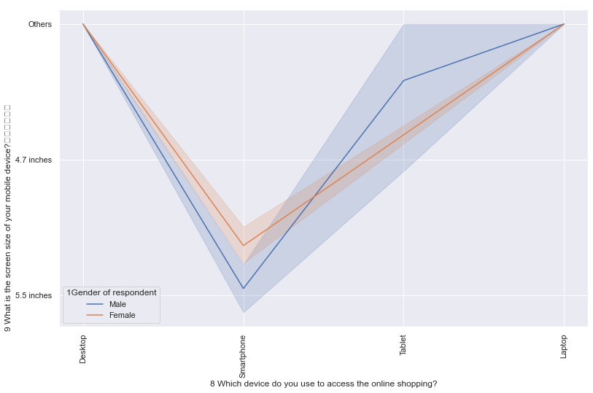

* Male individuals mainly use smartphones with 5.5 inches screen more than female individuals .

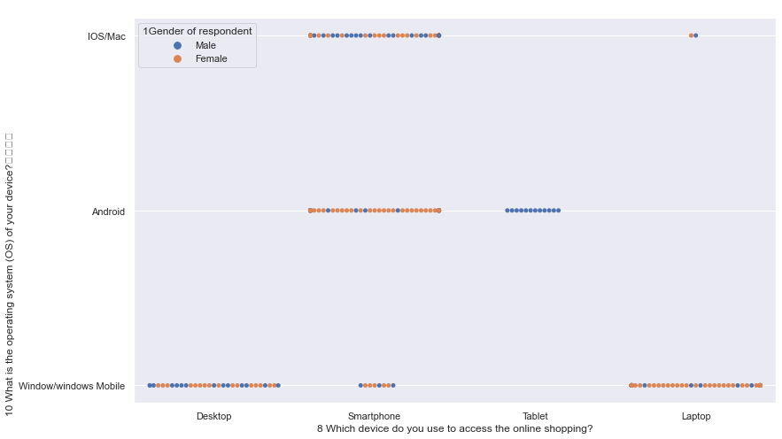

* Only male customers more use tablet with android OS. As desktop generally comes with windows, people use to do shopping with that also.
* **Conclusion**:

The dataset provided, had columns in the form of questionnaire that worked more like feedback. It was detailed having various information about many aspects of the customers who are currently shopping from an e-retail sectors. It showed that both male and females are inclined towards e- shopping. It has also shown that online sectors are the creating a boom in the spending habits of the customers and are in turn shaping their habits.

Now, the provided dataset is about 269 customers from Delhi, Greater Noida, Noida, Bangalore, Karnal, Solan, Ghaziabad, Gurgaon, Meerut, Moradabad, Blandisher who are asked 71 types of questions regarding e-commerce retail sectors to understand their point of view and experience. and we have analysed all the data thoroughly and closely and for that we can also say that it also serves as a survey of popularity of phones, popularity of web browsers. As per the analysis,

1. The most preferred website/application is **Anazon.in .**
2. The most involved gender, regarding online shopping is **Female.**
3. People mostly use **smartphones** to stop online.
4. To retain customers, websites should **fix their bugs** as sometimes during sale the applications get lagged.
5. The e-retailers should maintain their **quality** as people are always looking for better options. The analysis also goes on to show **gender based inclination** towards e-retail sectors. The dataset is particularly interesting as it showcases area based shopping experiences which is a clear reflection of growing digital India.

The dataset provides an insight into the likes and dislikes of the customers. Their preferences towards the devices they use while shopping. It was seen for **both sexes the device** **preferences** were different. It also showed that among the **five online** retailers which was the most preferred and why, thus helping to show **operational differences** among the online retailers. It would be interesting, if along with the basic analysis of the customer preferences if the spending activities could be monitored over a period of time, which would give an insight into the spending habits of the consumers.